A Mini Project Report

**On**

MEDI-CONNECT WEBSITE



**Submitted By**

**GAJULA MANI SUBRAHMANYA SWAMY**

**Regd. Number: 23B91A0577**

**DEPARTMENT OF COMPUTER SCIENCE ENGINEERING**

**S. R. K. R ENGINEERING COLLEGE (A)**

**(Affiliated to JNTU, KAKINADA)**

**BHIMAVARAM-534204 (2024-2025)**

**DEPARTMENT OF COMPUTER SCIENCE AND ENGINEERING**

**S. R. K. R ENGINEERING COLLEGE BHIMAVARAM**



***CERTIFICATE***

This is to certify that this is a bonafide work on “ MEDI-CONNECT ” for and has been submitted by Mr. GAJULA MANI SUBRAHMANYA SWAMY( 23B91A0577) as a **Full Stack Development -1** laboratory report, in partial fulfilment of the requirements for the award of the Degree of Bachelor of Technology in Computer Science and Engineering, during the academic year 2024-2025. The candidate worked right under my Supervision and guidance.

## Lecturers In-Charge

V. Priyadarshini

R. Leela Jyothi **Head of the Department**

B. Rekha Madhavi Dr. BH V S Rama Krishnam Raju

Assistant professor, Head of the Department,

Department of CSE, Department of CSE,

S.R.K.R. Engineering College, S.R.K.R. Engineering College,

Bhimavaram. Bhimavaram.

**ACKNOWLEDGEMENT**

I take immense pleasure in thanking **Dr. K.V. Murali Krishnam Raju,** beloved principal of S.R.K.R Engineering College, Bhimavaram, and **Dr. BH V S Rama Krishnam Raju,** esteemed **Head of the Department** (C.S.E), for having permitted me to carry out this **Full Stack Development -1** mini project work.

I wish to express my deep sense of gratitude especially to my project Guide**, Smt. V PRIYA DARSHINI, Assistant Professor, Smt. R.LEELA JYOTHI, Assistant Professor, Smt B.REKHA MADHAVI, Assistant Professor,** for their guidance and useful suggestions, which helped me in completing the project work, on time.

Finally, yet importantly, I would like to express my heartful thanks to my beloved parents, faculty, my friends/classmates for their help, and my wishes for the successful completion of this project.

GAJULA MANI SUBRAHMANYA SWAMY

23B91A0577

# TABLE OF CONTENTS

## S. No CONTENTS Page. No

1. ABSTRACT 5
2. MODULES 5
3. SOFTWARE REQUIREMENTS 5
4. HARDWARE REQUIREMENTS 5
5. TECHNICAL STACK 5
6. SAMPLE CODE 6-11
7. SCREENSHOTS 12-30
8. LAB PROGRAMS 31-

# ABSTRACT

The project is about Medi-Connect is a patient-centric healthcare platform that revolutionizes medical service accessibility through digital innovation. The website features real-time appointment booking with specialized doctors across departments including Cardiology, Neurology, and Pediatrics, complete with detailed physician profiles showcasing qualifications and availability. Its comprehensive service directory provides in-depth information about treatments, facilities, and emergency care protocols. The platform incorporates secure patient portals for medical history access and prescription management, while its responsive design ensures seamless access across devices.

Beyond core medical services, Medi-Connect enhances user experience with intelligent features like appointment reminders, telemedicine options, and emergency contact integration. The website maintains updated hospital information including operating hours, location maps, and department contacts. With robust data security measures and HIPAA-compliant communication channels, the platform bridges healthcare gaps by combining cutting-edge technology with patient-focused design, ultimately improving healthcare outcomes through digital empowerment and convenience**.**

# MODULES

* Home Page
* Services Page
* Doctor Profiles
* Appointment Page
* About Page
* Contact Information Page

**SOFTWARE REQUIREMENTS**

1. Development Tools:
   * Text Editor: Visual Studio Code, Sublime Text
   * Version Control: Git
2. Frontend Technologies:
   * HTML, CSS
   * JavaScript
3. Testing Browser:
   * Google Chrome (latest version)
   * Mozilla Firefox (latest version)
   * Microsoft Edge (latest version)

**HARDWARE REQUIREMENTS**

1. Processor-Intel Core I5
2. RAM-8GB

# TECHNICAL STACK

**HTML (HyperText Markup Language)**

* Provides the structural foundation for all web pages
* Uses semantic tags (<header>, <section>, <article>) for better accessibility and SEO
* Forms the basis for patient appointment forms and medical service listings
* Implements ARIA attributes for screen reader compatibility
* Organizes content hierarchically for clear information architecture

**CSS (Cascading Style Sheets)**

* Handles all visual presentation and responsive layouts
* Uses Flexbox/Grid for adaptive department/service listings
* Implements a medical-themed color scheme (#0066cc primary)
* Creates responsive breakpoints for mobile/tablet/desktop views
* Animates UI elements (buttons, hover states) for better UX
* Follows BEM methodology for maintainable class naming

**JavaScript (ES6+)**

* Powers interactive appointment scheduling functionality
* Handles form validation for patient registration/login
* Manages dynamic content loading (doctor profiles, services)
* Implements responsive navigation menu for mobile
* Controls interactive elements (accordions, modals)
* Integrates with backend APIs (when implemented)
* Stores temporary session data (cart-like functionality for appointments)

# SAMPLE CODE

1. **index.html:**

<html>

<head>

<title>Medi-Connect - Home</title>

<style>

* {

margin: 0;

padding: 0;

box-sizing: border-box;

font-family: 'Segoe UI', Tahoma, Geneva, Verdana, sans-serif;

}

body {

background-color: #f5f5f5;

color: #333;

line-height: 1.6;

}

.container {

max-width: 1200px;

margin: 0 auto;

padding: 0 20px;

}

header {

background-color: #0066cc;

color: white;

padding: 15px 0;

box-shadow: 0 2px 5px rgba(0,0,0,0.1);

}

.header-content {

display: flex;

justify-content: space-between;

align-items: center;

}

.logo {

font-size: 24px;

font-weight: bold;

}

nav ul {

display: flex;

list-style: none;

}

nav ul li {

margin-left: 20px;

}

nav ul li a {

color: white;

text-decoration: none;

padding: 5px 10px;

border-radius: 4px;

transition: background-color 0.3s;

}

nav ul li a:hover {

background-color: #0052a3;

}

.hero {

background-image: linear-gradient(rgba(0,0,0,0.5), rgba(0,0,0,0.5)), url('/api/placeholder/1200/400');

background-size: cover;

background-position: center;

height: 400px;

display: flex;

flex-direction: column;

justify-content: center;

align-items: center;

text-align: center;

color: white;

padding: 20px;

}

.hero h1 {

font-size: 48px;

margin-bottom: 20px;

}

.hero p {

font-size: 20px;

max-width: 800px;

margin-bottom: 30px;

}

.btn {

background-color: #0066cc;

color: white;

padding: 12px 24px;

border: none;

border-radius: 4px;

font-size: 16px;

cursor: pointer;

text-decoration: none;

transition: background-color 0.3s;

}

.btn:hover {

background-color: #0052a3;

}

.features {

padding: 60px 0;

}

.features-grid {

display: grid;

grid-template-columns: repeat(auto-fit, minmax(300px, 1fr));

gap: 30px;

margin-top: 40px;

}

.feature-card {

background-color: white;

border-radius: 8px;

overflow: hidden;

box-shadow: 0 4px 6px rgba(0,0,0,0.1);

transition: transform 0.3s;

}

.feature-card:hover {

transform: translateY(-5px);

}

.feature-card img {

width: 100%;

height: 200px;

object-fit: cover;

}

.feature-content {

padding: 20px;

}

.feature-content h3 {

margin-bottom: 10px;

color: #0066cc;

}

.section-title {

text-align: center;

margin-bottom: 20px;

color: #333;

}

.section-subtitle {

text-align: center;

max-width: 800px;

margin: 0 auto 40px;

color: #666;

}

.cta {

background-color: #0066cc;

color: white;

padding: 60px 0;

text-align: center;

}

.cta h2 {

margin-bottom: 20px;

}

.cta p {

max-width: 800px;

margin: 0 auto 30px;

}

footer {

background-color: #333;

color: white;

padding: 40px 0;

}

.footer-content {

display: grid;

grid-template-columns: repeat(auto-fit, minmax(200px, 1fr));

gap: 30px;

}

.footer-column h3 {

margin-bottom: 20px;

font-size: 18px;

}

.footer-column ul {

list-style: none;

}

.footer-column ul li {

margin-bottom: 10px;

}

.footer-column ul li a {

color: #ddd;

text-decoration: none;

transition: color 0.3s;

}

.footer-column ul li a:hover {

color: white;

}

.footer-bottom {

text-align: center;

padding-top: 40px;

color: #ddd;

}

/* Responsive */

@media (max-width: 768px) {

.header-content {

flex-direction: column;

}

nav ul {

margin-top: 20px;

}

.hero h1 {

font-size: 36px;

}

.hero p {

font-size: 16px;

}

}

</style>

</head>

<body>

<header>

<div class="container header-content">

<div class="logo">Medi-Connect</div>

<nav>

<ul>

<li><a href="index.html">Home</a></li>

<li><a href="services.html">Services</a></li>

<li><a href="doctors.html">Doctors</a></li>

<li><a href="appointments.html">Appointments</a></li>

<li><a href="about.html">About</a></li>

<li><a href="contact.html">Contact</a></li>

</ul>

</nav>

</div>

</header>

<section class="hero">

<h1>Welcome to Medi-Connect</h1>

<p>Providing comprehensive healthcare with compassion and excellence since 1985</p>

<a href="appointments.html" class="btn">Book an Appointment</a>

</section>

<section class="features container">

<h2 class="section-title">Our Services</h2>

<p class="section-subtitle">We offer a wide range of medical services with state-of-the-art facilities and experienced healthcare professionals</p>

<div class="features-grid">

<div class="feature-card">

<img src="/api/placeholder/400/200" alt="Emergency Care">

<div class="feature-content">

<h3>Emergency Care</h3>

<p>24/7 emergency services with rapid response teams for critical situations</p>

<a href="services.html#emergency" class="btn">Learn More</a>

</div>

</div>

<div class="feature-card">

<img src="/api/placeholder/400/200" alt="Specialized Treatment">

<div class="feature-content">

<h3>Specialized Treatment</h3>

<p>Advanced treatments for complex medical conditions by specialist doctors</p>

<a href="services.html#specialized" class="btn">Learn More</a>

</div>

</div>

<div class="feature-card">

<img src="/api/placeholder/400/200" alt="Preventive Care">

<div class="feature-content">

<h3>Preventive Care</h3>

<p>Comprehensive health check-ups and preventive healthcare programs</p>

<a href="services.html#preventive" class="btn">Learn More</a>

</div>

</div>

</div>

</section>

<section class="cta">

<div class="container">

<h2>Need Medical Assistance?</h2>

<p>Our dedicated team of healthcare professionals is ready to help you with any medical concerns</p>

<a href="contact.html" class="btn">Contact Us</a>

</div>

</section>

<footer>

<div class="container">

<div class="footer-content">

<div class="footer-column">

<h3>Quick Links</h3>

<ul>

<li><a href="index.html">Home</a></li>

<li><a href="services.html">Services</a></li>

<li><a href="doctors.html">Doctors</a></li>

<li><a href="appointments.html">Appointments</a></li>

<li><a href="about.html">About</a></li>

<li><a href="contact.html">Contact</a></li>

</ul>

</div>

<div class="footer-column">

<h3>Services</h3>

<ul>

<li><a href="services.html#emergency">Emergency Care</a></li>

<li><a href="services.html#pediatric">Pediatrics</a></li>

<li><a href="services.html#cardiology">Cardiology</a></li>

<li><a href="services.html#neurology">Neurology</a></li>

<li><a href="services.html#orthopedics">Orthopedics</a></li>

</ul>

</div>

<div class="footer-column">

<h3>Contact Info</h3>

<ul>

<li>123 Medical Dr, Healthcare City</li>

<li>Phone: (123) 456-7890</li>

<li>Emergency: (123) 456-7999</li>

<li>Email: info@mediconnect.com</li>

</ul>

</div>

<div class="footer-column">

<h3>Working Hours</h3>

<ul>

<li>Emergency: 24/7</li>

<li>Outpatient: Mon-Fri (8am-8pm)</li>

<li>Weekend: Sat (9am-5pm)</li>

<li>Laboratory: Mon-Sat (7am-7pm)</li>

</ul>

</div>

</div>

<div class="footer-bottom">

<p>&copy; 2025 Medi-Connect. All Rights Reserved.</p>

</div>

</div>

</footer>

</body>

</html>

**2.services.html:**

## <html>

## <head>

## <title>Medi-Connect - Services</title>

## <style>

## * {

## margin: 0;

## padding: 0;

## box-sizing: border-box;

## font-family: 'Segoe UI', Tahoma, Geneva, Verdana, sans-serif;

## }

## 

## body {

## background-color: #f5f5f5;

## color: #333;

## line-height: 1.6;

## }

## 

## .container {

## max-width: 1200px;

## margin: 0 auto;

## padding: 0 20px;

## }

## 

## header {

## background-color: #0066cc;

## color: white;

## padding: 15px 0;

## box-shadow: 0 2px 5px rgba(0,0,0,0.1);

## }

## 

## .header-content {

## display: flex;

## justify-content: space-between;

## align-items: center;

## }

## 

## .logo {

## font-size: 24px;

## font-weight: bold;

## }

## 

## nav ul {

## display: flex;

## list-style: none;

## }

## 

## nav ul li {

## margin-left: 20px;

## }

## 

## nav ul li a {

## color: white;

## text-decoration: none;

## padding: 5px 10px;

## border-radius: 4px;

## transition: background-color 0.3s;

## }

## 

## nav ul li a:hover {

## background-color: #0052a3;

## }

## 

## .page-header {

## background-color: #0066cc;

## padding: 60px 0;

## color: white;

## text-align: center;

## }

## 

## .page-header h1 {

## font-size: 36px;

## margin-bottom: 20px;

## }

## 

## .page-header p {

## max-width: 800px;

## margin: 0 auto;

## font-size: 18px;

## }

## 

## .services {

## padding: 60px 0;

## }

## 

## .service-item {

## background-color: white;

## border-radius: 8px;

## overflow: hidden;

## box-shadow: 0 4px 6px rgba(0,0,0,0.1);

## margin-bottom: 30px;

## display: flex;

## flex-direction: column;

## }

## 

## @media (min-width: 768px) {

## .service-item {

## flex-direction: row;

## }

## }

## 

## .service-image {

## flex: 1;

## min-height: 300px;

## background-size: cover;

## background-position: center;

## }

## 

## .service-content {

## flex: 2;

## padding: 30px;

## }

## 

## .service-content h2 {

## color: #0066cc;

## margin-bottom: 15px;

## }

## 

## .service-content ul {

## margin: 15px 0;

## padding-left: 20px;

## }

## 

## .service-content .btn {

## display: inline-block;

## background-color: #0066cc;

## color: white;

## padding: 10px 20px;

## border-radius: 4px;

## text-decoration: none;

## margin-top: 15px;

## transition: background-color 0.3s;

## }

## 

## .service-content .btn:hover {

## background-color: #0052a3;

## }

## 

## footer {

## background-color: #333;

## color: white;

## padding: 40px 0;

## }

## 

## .footer-content {

## display: grid;

## grid-template-columns: repeat(auto-fit, minmax(200px, 1fr));

## gap: 30px;

## }

## 

## .footer-column h3 {

## margin-bottom: 20px;

## font-size: 18px;

## }

## 

## .footer-column ul {

## list-style: none;

## }

## 

## .footer-column ul li {

## margin-bottom: 10px;

## }

## 

## .footer-column ul li a {

## color: #ddd;

## text-decoration: none;

## transition: color 0.3s;

## }

## 

## .footer-column ul li a:hover {

## color: white;

## }

## 

## .footer-bottom {

## text-align: center;

## padding-top: 40px;

## color: #ddd;

## }

## </style>

## </head>

## <body>

## <header>

## <div class="container header-content">

## <div class="logo">Medi-Connect</div>

## <nav>

## <ul>

## <li><a href="index.html">Home</a></li>

## <li><a href="services.html">Services</a></li>

## <li><a href="doctors.html">Doctors</a></li>

## <li><a href="appointments.html">Appointments</a></li>

## <li><a href="about.html">About</a></li>

## <li><a href="contact.html">Contact</a></li>

## </ul>

## </nav>

## </div>

## </header>

## 

## <section class="page-header">

## <div class="container">

## <h1>Our Medical Services</h1>

## <p>Comprehensive healthcare solutions for you and your family with cutting-edge technology and expert professionals</p>

## </div>

## </section>

## 

## <section class="services container">

## <div id="emergency" class="service-item">

## <div class="service-image" style="background-image: url('/api/placeholder/600/400')"></div>

## <div class="service-content">

## <h2>Emergency Care</h2>

## <p>Our emergency department operates 24/7 to provide immediate medical attention for life-threatening conditions. Equipped with advanced technology and staffed by experienced emergency physicians and nurses.</p>

## <ul>

## <li>24/7 Emergency Services</li>

## <li>Trauma Care Units</li>

## <li>Rapid Response Teams</li>

## <li>Advanced Life Support</li>

## <li>Critical Care Transport</li>

## </ul>

## <a href="appointments.html" class="btn">Book Now</a>

## </div>

## </div>

## 

## <div id="pediatric" class="service-item">

## <div class="service-image" style="background-image: url('/api/placeholder/600/400')"></div>

## <div class="service-content">

## <h2>Pediatrics</h2>

## <p>Our pediatric department provides comprehensive healthcare for infants, children, and adolescents. From routine check-ups to specialized care for complex conditions, our pediatricians ensure the health and well-being of your children.</p>

## <ul>

## <li>Well-Child Visits</li>

## <li>Immunizations</li>

## <li>Developmental Assessments</li>

## <li>Pediatric Specialties</li>

## <li>Child-Friendly Environment</li>

## </ul>

## <a href="appointments.html" class="btn">Book Now</a>

## </div>

## </div>

## 

## <div id="cardiology" class="service-item">

## <div class="service-image" style="background-image: url('/api/placeholder/600/400')"></div>

## <div class="service-content">

## <h2>Cardiology</h2>

## <p>Our cardiology department offers comprehensive diagnostic and treatment services for heart conditions. Our cardiologists use advanced technology to provide accurate diagnoses and effective treatment plans.</p>

## <ul>

## <li>Heart Disease Diagnosis</li>

## <li>Cardiac Imaging</li>

## <li>Interventional Cardiology</li>

## <li>Electrophysiology</li>

## <li>Cardiac Rehabilitation</li>

## </ul>

## <a href="appointments.html" class="btn">Book Now</a>

## </div>

## </div>

## 

## <div id="neurology" class="service-item">

## <div class="service-image" style="background-image: url('/api/placeholder/600/400')"></div>

## <div class="service-content">

## <h2>Neurology</h2>

## <p>Our neurology department specializes in diagnosing and treating disorders of the nervous system. Our neurologists and neurosurgeons provide expert care for conditions affecting the brain, spinal cord, and nerves.</p>

## <ul>

## <li>Neurological Evaluations</li>

## <li>Neuroimaging</li>

## <li>Treatment for Neurological Disorders</li>

## <li>Neurosurgery</li>

## <li>Neurorehabilitation</li>

## </ul>

## <a href="appointments.html" class="btn">Book Now</a>

## </div>

## </div>

## 

## <div id="orthopedics" class="service-item">

## <div class="service-image" style="background-image: url('/api/placeholder/600/400')"></div>

## <div class="service-content">

## <h2>Orthopedics</h2>

## <p>Our orthopedic department focuses on the diagnosis, treatment, and prevention of disorders of the musculoskeletal system. Our orthopedic surgeons and specialists provide comprehensive care for bone, joint, ligament, tendon, and muscle conditions.</p>

## <ul>

## <li>Joint Replacement Surgery</li>

## <li>Sports Medicine</li>

## <li>Spine Surgery</li>

## <li>Trauma Care</li>

## <li>Physical Therapy</li>

## </ul>

## <a href="appointments.html" class="btn">Book Now</a>

## </div>

## </div>

## 

## <div id="specialized" class="service-item">

## <div class="service-image" style="background-image: url('/api/placeholder/600/400')"></div>

## <div class="service-content">

## <h2>Specialized Treatments</h2>

## <p>We offer advanced specialized treatments for complex medical conditions, performed by highly trained specialists using cutting-edge technology and techniques.</p>

## <ul>

## <li>Minimally Invasive Surgery</li>

## <li>Cancer Treatment</li>

## <li>Advanced Imaging</li>

## <li>Transplant Services</li>

## <li>Genetic Counseling</li>

## </ul>

## <a href="appointments.html" class="btn">Book Now</a>

## </div>

## </div>

## 

## <div id="preventive" class="service-item">

## <div class="service-image" style="background-image: url('/api/placeholder/600/400')"></div>

## <div class="service-content">

## <h2>Preventive Care</h2>

## <p>Our preventive care services focus on maintaining good health and preventing diseases. We offer comprehensive health check-ups and preventive healthcare programs tailored to individual needs.</p>

## <ul>

## <li>Health Screenings</li>

## <li>Vaccination Programs</li>

## <li>Lifestyle Counseling</li>

## <li>Chronic Disease Management</li>

## <li>Nutrition and Diet Planning</li>

## </ul>

## <a href="appointments.html" class="btn">Book Now</a>

## </div>

## </div>

## </section>

## 

## <footer>

## <div class="container">

## <div class="footer-content">

## <div class="footer-column">

## <h3>Quick Links</h3>

## <ul>

## <li><a href="index.html">Home</a></li>

## <li><a href="services.html">Services</a></li>

## <li><a href="doctors.html">Doctors</a></li>

## <li><a href="appointments.html">Appointments</a></li>

## <li><a href="about.html">About</a></li>

## <li><a href="contact.html">Contact</a></li>

## </ul>

## </div>

## 

## <div class="footer-column">

## <h3>Services</h3>

## <ul>

## <li><a href="services.html#emergency">Emergency Care</a></li>

## <li><a href="services.html#pediatric">Pediatrics</a></li>

## <li><a href="services.html#cardiology">Cardiology</a></li>

## <li><a href="services.html#neurology">Neurology</a></li>

## <li><a href="services.html#orthopedics">Orthopedics</a></li>

## </ul>

## </div>

## 

## <div class="footer-column">

## <h3>Contact Info</h3>

## <ul>

## <li>123 Medical Dr, Healthcare City</li>

## <li>Phone: (123) 456-7890</li>

## <li>Emergency: (123) 456-7999</li>

## <li>Email: info@mediconnect.com</li>

## </ul>

## </div>

## 

## <div class="footer-column">

## <h3>Working Hours</h3>

## <ul>

## <li>Emergency: 24/7</li>

## <li>Outpatient: Mon-Fri (8am-8pm)</li>

## <li>Weekend: Sat (9am-5pm)</li>

## <li>Laboratory: Mon-Sat (7am-7pm)</li>

## </ul>

## </div>

## </div>

## 

## <div class="footer-bottom">

## <p>&copy; 2025 Medi-Connect. All Rights Reserved.</p>

## </div>

## </div>

## </footer>

## </body>

## </html>

## 3.doctors.html:

<html>

<head>

<title>Medi-Connect - Our Doctors</title>

<style>

* {

margin: 0;

padding: 0;

box-sizing: border-box;

font-family: 'Segoe UI', Tahoma, Geneva, Verdana, sans-serif;

}

body {

background-color: #f5f5f5;

color: #333;

line-height: 1.6;

}

.container {

max-width: 1200px;

margin: 0 auto;

padding: 0 20px;

}

header {

background-color: #0066cc;

color: white;

padding: 15px 0;

box-shadow: 0 2px 5px rgba(0,0,0,0.1);

}

.header-content {

display: flex;

justify-content: space-between;

align-items: center;

}

.logo {

font-size: 24px;

font-weight: bold;

}

nav ul {

display: flex;

list-style: none;

}

nav ul li {

margin-left: 20px;

}

nav ul li a {

color: white;

text-decoration: none;

padding: 5px 10px;

border-radius: 4px;

transition: background-color 0.3s;

}

nav ul li a:hover {

background-color: #0052a3;

}

.page-header {

background-color: #0066cc;

padding: 60px 0;

color: white;

text-align: center;

}

.page-header h1 {

font-size: 36px;

margin-bottom: 20px;

}

.page-header p {

max-width: 800px;

margin: 0 auto;

font-size: 18px;

}

.doctors {

padding: 60px 0;

}

.departments-filter {

margin-bottom: 30px;

text-align: center;

}

.filter-btn {

background-color: transparent;

border: 1px solid #0066cc;

color: #0066cc;

padding: 8px 16px;

margin: 5px;

border-radius: 4px;

cursor: pointer;

transition: all 0.3s;

}

.filter-btn:hover, .filter-btn.active {

background-color: #0066cc;

color: white;

}

.doctors-grid {

display: grid;

grid-template-columns: repeat(auto-fill, minmax(280px, 1fr));

gap: 30px;

}

.doctor-card {

background-color: white;

border-radius: 8px;

overflow: hidden;

box-shadow: 0 4px 6px rgba(0,0,0,0.1);

transition: transform 0.3s;

}

.doctor-card:hover {

transform: translateY(-5px);

}

.doctor-image {

width: 100%;

height: 300px;

object-fit: cover;

}

.doctor-info {

padding: 20px;

}

.doctor-info h3 {

color: #0066cc;

margin-bottom: 5px;

}

.doctor-department {

color: #666;

font-style: italic;

margin-bottom: 10px;

}

.doctor-qualification {

margin-bottom: 10px;

font-size: 14px;

}

.doctor-buttons {

display: flex;

gap: 10px;

margin-top: 15px;

}

.doctor-btn {

flex: 1;

padding: 8px 16px;

border-radius: 4px;

text-align: center;

text-decoration: none;

transition: all 0.3s;

}

.profile-btn {

background-color: transparent;

border: 1px solid #0066cc;

color: #0066cc;

}

.profile-btn:hover {

background-color: rgba(0, 102, 204, 0.1);

}

.appointment-btn {

background-color: #0066cc;

color: white;

border: 1px solid #0066cc;

}

.appointment-btn:hover {

background-color: #0052a3;

}

footer {

background-color: #333;

color: white;

padding: 40px 0;

}

.footer-content {

display: grid;

grid-template-columns: repeat(auto-fit, minmax(200px, 1fr));

gap: 30px;

}

.footer-column h3 {

margin-bottom: 20px;

font-size: 18px;

}

.footer-column ul {

list-style: none;

}

.footer-column ul li {

margin-bottom: 10px;

}

.footer-column ul li a {

color: #ddd;

text-decoration: none;

transition: color 0.3s;

}

.footer-column ul li a:hover {

color: white;

}

.footer-bottom {

text-align: center;

padding-top: 40px;

color: #ddd;

}

</style>

</head>

<body>

<header>

<div class="container header-content">

<div class="logo">Medi-Connect</div>

<nav>

<ul>

<li><a href="index.html">Home</a></li>

<li><a href="services.html">Services</a></li>

<li><a href="doctors.html">Doctors</a></li>

<li><a href="appointments.html">Appointments</a></li>

<li><a href="about.html">About</a></li>

<li><a href="contact.html">Contact</a></li>

</ul>

</nav>

</div>

</header>

<section class="page-header">

<div class="container">

<h1>Our Medical Team</h1>

<p>Meet our highly qualified and experienced healthcare professionals dedicated to providing the best medical care</p>

</div>

</section>

<section class="doctors container">

<div class="departments-filter">

<button class="filter-btn active">All Departments</button>

<button class="filter-btn">Cardiology</button>

<button class="filter-btn">Neurology</button>

<button class="filter-btn">Pediatrics</button>

<button class="filter-btn">Orthopedics</button>

<button class="filter-btn">Emergency Medicine</button>

</div>

<div class="doctors-grid">

<div class="doctor-card">

<img src="/api/placeholder/300/300" alt="Dr. Sarah Johnson" class="doctor-image">

<div class="doctor-info">

<h3>Dr. Sarah Johnson</h3>

<div class="doctor-department">Cardiology</div>

<div class="doctor-qualification">MD, FACC - Cardiology Specialist</div>

<p>Dr. Johnson specializes in interventional cardiology and has over 15 years of experience in treating heart diseases.</p>

<div class="doctor-buttons">

<a href="#" class="doctor-btn profile-btn">View Profile</a>

<a href="appointments.html" class="doctor-btn appointment-btn">Book Appointment</a>

</div>

</div>

</div>

<div class="doctor-card">

<img src="/api/placeholder/300/300" alt="Dr. Michael Chen" class="doctor-image">

<div class="doctor-info">

<h3>Dr. Michael Chen</h3>

<div class="doctor-department">Neurology</div>

<div class="doctor-qualification">MD, PhD - Neurosurgery</div>

<p>Dr. Chen is a renowned neurosurgeon specializing in complex brain surgeries and neurological disorders.</p>

<div class="doctor-buttons">

<a href="#" class="doctor-btn profile-btn">View Profile</a>

<a href="appointments.html" class="doctor-btn appointment-btn">Book Appointment</a>

</div>

</div>

</div>

<div class="doctor-card">

<img src="/api/placeholder/300/300" alt="Dr. Emily Rodriguez" class="doctor-image">

<div class="doctor-info">

<h3>Dr. Emily Rodriguez</h3>

<div class="doctor-department">Pediatrics</div>

<div class="doctor-qualification">MD, FAAP - Pediatric Specialist</div>

<p>Dr. Rodriguez has dedicated her career to providing comprehensive healthcare for children of all ages.</p>

<div class="doctor-buttons">

<a href="#" class="doctor-btn profile-btn">View Profile</a>

<a href="appointments.html" class="doctor-btn appointment-btn">Book Appointment</a>

</div>

</div>

</div>

<div class="doctor-card">

<img src="/api/placeholder/300/300" alt="Dr. James Wilson" class="doctor-image">

<div class="doctor-info">

<h3>Dr. James Wilson</h3>

<div class="doctor-department">Orthopedics</div>

<div class="doctor-qualification">MD, FAAOS - Orthopedic Surgeon</div>

<p>Dr. Wilson specializes in joint replacement surgery and sports medicine with over 12 years of experience.</p>

<div class="doctor-buttons">

<a href="#" class="doctor-btn profile-btn">View Profile</a>

<a href="appointments.html" class="doctor-btn appointment-btn">Book Appointment</a>

</div>

</div>

</div>

<div class="doctor-card">

<img src="/api/placeholder/300/300" alt="Dr. Lisa Patel" class="doctor-image">

<div class="doctor-info">

<h3>Dr. Lisa Patel</h3>

<div class="doctor-department">Emergency Medicine</div>

<div class="doctor-qualification">MD, FACEP - Emergency Physician</div>

<p>Dr. Patel is an experienced emergency medicine physician specialized in trauma care and critical interventions.</p>

<div class="doctor-buttons">

<a href="#" class="doctor-btn profile-btn">View Profile</a>

<a href="appointments.html" class="doctor-btn appointment-btn">Book Appointment</a>

</div>

</div>

</div>

<div class="doctor-card">

<img src="/api/placeholder/300/300" alt="Dr. Robert Kim" class="doctor-image">

<div class="doctor-info">

<h3>Dr. Robert Kim</h3>

<div class="doctor-department">Cardiology</div>

<div class="doctor-qualification">MD, FACC - Electrophysiologist</div>

<p>Dr. Kim specializes in cardiac electrophysiology and the treatment of heart rhythm disorders.</p>

<div class="doctor-buttons">

<a href="#" class="doctor-btn profile-btn">View Profile</a>

<a href="appointments.html" class="doctor-btn appointment-btn">Book Appointment</a>

</div>

</div>

</div>

<div class="doctor-card">

<img src="/api/placeholder/300/300" alt="Dr. Sophia Martinez" class="doctor-image">

<div class="doctor-info">

<h3>Dr. Sophia Martinez</h3>

<div class="doctor-department">Neurology</div>

<div class="doctor-qualification">MD - Neurologist</div>

<p>Dr. Martinez specializes in the diagnosis and treatment of complex neurological disorders and conditions.</p>

<div class="doctor-buttons">

<a href="#" class="doctor-btn profile-btn">View Profile</a>

<a href="appointments.html" class="doctor-btn appointment-btn">Book Appointment</a>

</div>

</div>

</div>

<div class="doctor-card">

<img src="/api/placeholder/300/300" alt="Dr. David Thompson" class="doctor-image">

<div class="doctor-info">

<h3>Dr. David Thompson</h3>

<div class="doctor-department">Orthopedics</div>

<div class="doctor-qualification">MD - Spine Specialist</div>

<p>Dr. Thompson is specialized in spine surgery and the treatment of spinal disorders and injuries.</p>

<div class="doctor-buttons">

<a href="#" class="doctor-btn profile-btn">View Profile</a>

<a href="appointments.html" class="doctor-btn appointment-btn">Book Appointment</a>

</div>

</div>

</div>

</div>

</section>

<footer>

<div class="container">

<div class="footer-content">

<div class="footer-column">

<h3>Quick Links</h3>

<ul>

<li><a href="index.html">Home</a></li>

<li><a href="services.html">Services</a></li>

<li><a href="doctors.html">Doctors</a></li>

<li><a href="appointments.html">Appointments</a></li>

<li><a href="about.html">About</a></li>

<li><a href="contact.html">Contact</a></li>

</ul>

</div>

<div class="footer-column">

<h3>Services</h3>

<ul>

<li><a href="services.html#emergency">Emergency Care</a></li>

<li><a href="services.html#pediatric">Pediatrics</a></li>

<li><a href="services.html#cardiology">Cardiology</a></li>

<li><a href="services.html#neurology">Neurology</a></li>

<li><a href="services.html#orthopedics">Orthopedics</a></li>

</ul>

</div>

<div class="footer-column">

<h3>Contact Info</h3>

<ul>

<li>123 Medical Dr, Healthcare City</li>

<li>Phone: (123) 456-7890</li>

<li>Emergency: (123) 456-7999</li>

<li>Email: info@mediconnect.com</li>

</ul>

</div>

<div class="footer-column">

<h3>Working Hours</h3>

<ul>

<li>Emergency: 24/7</li>

<li>Outpatient: Mon-Fri (8am-8pm)</li>

<li>Weekend: Sat (9am-5pm)</li>

<li>Laboratory: Mon-Sat (7am-7pm)</li>

</ul>

</div>

</div>

<div class="footer-bottom">

<p>&copy; 2025 Medi-Connect. All Rights Reserved.</p>

</div>

</div>

</footer>

</body>

</html>

**4,appointments.html:**

<html>

<head>

<title>Medi-Connect - Book an Appointment</title>

<style>

* {

margin: 0;

padding: 0;

box-sizing: border-box;

font-family: 'Segoe UI', Tahoma, Geneva, Verdana, sans-serif;

}

body {

background-color: #f5f5f5;

color: #333;

line-height: 1.6;

}

.container {

max-width: 1200px;

margin: 0 auto;

padding: 0 20px;

}

header {

background-color: #0066cc;

color: white;

padding: 15px 0;

box-shadow: 0 2px 5px rgba(0,0,0,0.1);

}

.header-content {

display: flex;

justify-content: space-between;

align-items: center;

}

.logo {

font-size: 24px;

font-weight: bold;

}

nav ul {

display: flex;

list-style: none;

}

nav ul li {

margin-left: 20px;

}

nav ul li a {

color: white;

text-decoration: none;

padding: 5px 10px;

border-radius: 4px;

transition: background-color 0.3s;

}

nav ul li a:hover {

background-color: #0052a3;

}

.page-header {

background-color: #0066cc;

padding: 60px 0;

color: white;

text-align: center;

}

.page-header h1 {

font-size: 36px;

margin-bottom: 20px;

}

.page-header p {

max-width: 800px;

margin: 0 auto;

font-size: 18px;

}

.appointment-section {

padding: 60px 0;

}

.appointment-container {

display: grid;

grid-template-columns: 1fr 1fr;

gap: 40px;

}

@media (max-width: 768px) {

.appointment-container {

grid-template-columns: 1fr;

}

}

.appointment-form {

background-color: white;

padding: 30px;

border-radius: 8px;

box-shadow: 0 4px 6px rgba(0,0,0,0.1);

}

.appointment-info {

display: flex;

flex-direction: column;

justify-content: space-between;

}

.info-card {

background-color: white;

padding: 20px;

border-radius: 8px;

box-shadow: 0 4px 6px rgba(0,0,0,0.1);

margin-bottom: 20px;

}

.info-card h3 {

color: #0066cc;

margin-bottom: 15px;

padding-bottom: 10px;

border-bottom: 1px solid #eee;

}

.info-card ul {

list-style: none;

}

.info-card ul li {

margin-bottom: 10px;

padding-left: 20px;

position: relative;

}

.info-card ul li:before {

content: "•";

position: absolute;

left: 0;

color: #0066cc;

}

.form-group {

margin-bottom: 20px;

}

.form-group label {

display: block;

margin-bottom: 8px;

font-weight: 600;

}

.form-control {

width: 100%;

padding: 10px;

border: 1px solid #ddd;

border-radius: 4px;

font-size: 16px;

}

.form-control:focus {

border-color: #0066cc;

outline: none;

}

.form-row {

display: flex;

gap: 20px;

}

.form-row .form-group {

flex: 1;

}

.btn {

background-color: #0066cc;

color: white;

padding: 12px 24px;

border: none;

border-radius: 4px;

font-size: 16px;

cursor: pointer;

transition: background-color 0.3s;

}

.btn:hover {

background-color: #0052a3;

}

.emergency-contact {

background-color: #f44336;

color: white;

padding: 20px;

border-radius: 8px;

text-align: center;

}

.emergency-contact h3 {

margin-bottom: 10px;

}

.emergency-contact .phone {

font-size: 24px;

font-weight: bold;

margin: 10px 0;

}

footer {

background-color: #333;

color: white;

padding: 40px 0;

}

.footer-content {

display: grid;

grid-template-columns: repeat(auto-fit, minmax(200px, 1fr));

gap: 30px;

}

.footer-column h3 {

margin-bottom: 20px;

font-size: 18px;

}

.footer-column ul {

list-style: none;

}

.footer-column ul li {

margin-bottom: 10px;

}

.footer-column ul li a {

color: #ddd;

text-decoration: none;

transition: color 0.3s;

}

.footer-column ul li a:hover {

color: white;

}

.footer-bottom {

text-align: center;

padding-top: 40px;

color: #ddd;

}

</style>

</head>

<body>

<header>

<div class="container header-content">

<div class="logo">Medi-Connect</div>

<nav>

<ul>

<li><a href="index.html">Home</a></li>

<li><a href="services.html">Services</a></li>

<li><a href="doctors.html">Doctors</a></li>

<li><a href="appointments.html">Appointments</a></li>

<li><a href="about.html">About</a></li>

<li><a href="contact.html">Contact</a></li>

</ul>

</nav>

</div>

</header>

<section class="page-header">

<div class="container">

<h1>Book an Appointment</h1>

<p>Schedule a visit with our healthcare professionals for consultation, check-ups, or treatments</p>

</div>

</section>

<section class="appointment-section container">

<div class="appointment-container">

<div class="appointment-form">

<h2>Appointment Request Form</h2>

<p>Fill in the form below and we'll get back to you with confirmation shortly.</p>

<form id="appointment-form">

<div class="form-group">

<label for="patient-name">Full Name *</label>

<input type="text" id="patient-name" class="form-control" required>

</div>

<div class="form-row">

<div class="form-group">

<label for="patient-email">Email Address *</label>

<input type="email" id="patient-email" class="form-control" required>

</div>

<div class="form-group">

<label for="patient-phone">Phone Number *</label>

<input type="tel" id="patient-phone" class="form-control" required>

</div>

</div>

<div class="form-group">

<label for="department">Department *</label>

<select id="department" class="form-control" required>

<option value="">-- Select Department --</option>

<option value="cardiology">Cardiology</option>

<option value="neurology">Neurology</option>

<option value="pediatrics">Pediatrics</option>

<option value="orthopedics">Orthopedics</option>

<option value="general">General Medicine</option>

</select>

</div>

<div class="form-group">

<label for="doctor">Preferred Doctor</label>

<select id="doctor" class="form-control">

<option value="">-- Select Doctor --</option>

<option value="dr-johnson">Dr. Sarah Johnson - Cardiology</option>

<option value="dr-chen">Dr. Michael Chen - Neurology</option>

<option value="dr-rodriguez">Dr. Emily Rodriguez - Pediatrics</option>

<option value="dr-wilson">Dr. James Wilson - Orthopedics</option>

<option value="dr-any">Any Available Doctor</option>

</select>

</div>

<div class="form-row">

<div class="form-group">

<label for="appointment-date">Preferred Date *</label>

<input type="date" id="appointment-date" class="form-control" required>

</div>

<div class="form-group">

<label for="appointment-time">Preferred Time *</label>

<select id="appointment-time" class="form-control" required>

<option value="">-- Select Time --</option>

<option value="morning">Morning (9AM - 12PM)</option>

<option value="afternoon">Afternoon (1PM - 5PM)</option>

<option value="evening">Evening (6PM - 8PM)</option>

</select>

</div>

</div>

<div class="form-group">

<label for="reason">Reason for Appointment *</label>

<textarea id="reason" class="form-control" rows="4" required></textarea>

</div>

<div class="form-group">

<button type="submit" class="btn">Submit Appointment Request</button>

</div>

</form>

</div>

<div class="appointment-info">

<div class="info-card">

<h3>Appointment Guidelines</h3>

<ul>

<li>Please arrive 15 minutes before your scheduled appointment time.</li>

<li>Bring your ID, insurance card, and any relevant medical records.</li>

<li>If you need to cancel or reschedule, please call at least 24 hours in advance.</li>

<li>Wear comfortable clothing suitable for medical examination.</li>

<li>Prepare a list of questions you may have for the doctor.</li>

</ul>

</div>

<div class="info-card">

<h3>Working Hours</h3>

<ul>

<li><strong>Emergency Department:</strong> 24/7, all days</li>

<li><strong>Outpatient Clinics:</strong> Monday-Friday (8AM - 8PM)</li>

<li><strong>Weekend Clinics:</strong> Saturday (9AM - 5PM)</li>

<li><strong>Laboratory Services:</strong> Monday-Saturday (7AM - 7PM)</li>

</ul>

</div>

<div class="emergency-contact">

<h3>Emergency? Don't Wait, Call Immediately</h3>

<div class="phone">(123) 456-7999</div>

<p>Our emergency department is available 24/7 for urgent medical care.</p>

</div>

</div>

</div>

</section>

<footer>

<div class="container">

<div class="footer-content">

<div class="footer-column">

<h3>Quick Links</h3>

<ul>

<li><a href="index.html">Home</a></li>

<li><a href="services.html">Services</a></li>

<li><a href="doctors.html">Doctors</a></li>

<li><a href="appointments.html">Appointments</a></li>

<li><a href="about.html">About</a></li>

<li><a href="contact.html">Contact</a></li>

</ul>

</div>

<div class="footer-column">

<h3>Services</h3>

<ul>

<li><a href="services.html#emergency">Emergency Care</a></li>

<li><a href="services.html#pediatric">Pediatrics</a></li>

<li><a href="services.html#cardiology">Cardiology</a></li>

<li><a href="services.html#neurology">Neurology</a></li>

<li><a href="services.html#orthopedics">Orthopedics</a></li>

</ul>

</div>

<div class="footer-column">

<h3>Contact Info</h3>

<ul>

<li>123 Medical Dr, Healthcare City</li>

<li>Phone: (123) 456-7890</li>

<li>Emergency: (123) 456-7999</li>

<li>Email: info@mediconnect.com</li>

</ul>

</div>

<div class="footer-column">

<h3>Working Hours</h3>

<ul>

<li>Emergency: 24/7</li>

<li>Outpatient: Mon-Fri (8am-8pm)</li>

<li>Weekend: Sat (9am-5pm)</li>

<li>Laboratory: Mon-Sat (7am-7pm)</li>

</ul>

</div>

</div>

<div class="footer-bottom">

<p>&copy; 2025 Medi-Connect. All Rights Reserved.</p>

</div>

</div>

</footer>

</body>

</html>

**5.about.html**

<html>

<head>

<title> Medi-Connect - About Us</title>

<style>

* {

margin: 0;

padding: 0;

box-sizing: border-box;

font-family: 'Segoe UI', Tahoma, Geneva, Verdana, sans-serif;

}

body {

background-color: #f5f5f5;

color: #333;

line-height: 1.6;

}

.container {

max-width: 1200px;

margin: 0 auto;

padding: 0 20px;

}

header {

background-color: #0066cc;

color: white;

padding: 15px 0;

box-shadow: 0 2px 5px rgba(0,0,0,0.1);

}

.header-content {

display: flex;

justify-content: space-between;

align-items: center;

}

.logo {

font-size: 24px;

font-weight: bold;

}

nav ul {

display: flex;

list-style: none;

}

nav ul li {

margin-left: 20px;

}

nav ul li a {

color: white;

text-decoration: none;

padding: 5px 10px;

border-radius: 4px;

transition: background-color 0.3s;

}

nav ul li a:hover {

background-color: #0052a3;

}

.page-header {

background-color: #0066cc;

padding: 60px 0;

color: white;

text-align: center;

}

.page-header h1 {

font-size: 36px;

margin-bottom: 20px;

}

.page-header p {

max-width: 800px;

margin: 0 auto;

font-size: 18px;

}

.about-section {

padding: 60px 0;

}

.about-content {

display: grid;

grid-template-columns: 1fr 1fr;

gap: 40px;

align-items: center;

margin-bottom: 60px;

}

@media (max-width: 768px) {

.about-content {

grid-template-columns: 1fr;

}

}

.about-image {

border-radius: 8px;

overflow: hidden;

box-shadow: 0 4px 6px rgba(0,0,0,0.1);

}

.about-image img {

width: 100%;

display: block;

}

.about-text h2 {

color: #0066cc;

margin-bottom: 20px;

}

.about-text p {

margin-bottom: 15px;

}

.mission-vision {

background-color: white;

padding: 60px 0;

margin: 60px 0;

}

.mission-vision-content {

display: grid;

grid-template-columns: repeat(auto-fit, minmax(300px, 1fr));

gap: 30px;

}

.mv-card {

padding: 30px;

border-radius: 8px;

box-shadow: 0 4px 6px rgba(0,0,0,0.1);

text-align: center;

}

.mv-card h3 {

color: #0066cc;

margin-bottom: 20px;

font-size: 24px;

}

.mv-card p {

font-size: 16px;

}

.values-card {

background-color: #0066cc;

color: white;

}

.timeline {

position: relative;

padding: 40px 0;

}

.timeline-title {

text-align: center;

margin-bottom: 40px;

}

.timeline-title h2 {

color: #0066cc;

margin-bottom: 15px;

}

.timeline::before {

content: '';

position: absolute;

height: 100%;

width: 4px;

background-color: #0066cc;

left: 50%;

transform: translateX(-50%);

top: 0;

}

.timeline-item {

margin-bottom: 30px;

position: relative;

width: 50%;

padding: 0 30px;

}

.timeline-item:nth-child(odd) {

left: 0;

text-align: right;

}

.timeline-item:nth-child(even) {

left: 50%;

}

.timeline-content {

background-color: white;

padding: 20px;

border-radius: 8px;

box-shadow: 0 4px 6px rgba(0,0,0,0.1);

}

.timeline-content h3 {

color: #0066cc;

margin-bottom: 10px;

}

.timeline-date {

position: absolute;

top: 0;

background-color: #0066cc;

color: white;

padding: 5px 15px;

border-radius: 20px;

}

.timeline-item:nth-child(odd) .timeline-date {

right: -140px;

}

.timeline-item:nth-child(even) .timeline-date {

left: -140px;

}

@media (max-width: 768px) {

.timeline::before {

left: 40px;

}

.timeline-item {

width: 100%;

padding-left: 70px;

padding-right: 0;

text-align: left;

}

.timeline-item:nth-child(odd) {

text-align: left;

}

.timeline-item:nth-child(even) {

left: 0;

}

.timeline-item:nth-child(odd) .timeline-date,

.timeline-item:nth-child(even) .timeline-date {

left: -30px;

top: 20px;

}

}

.team-section {

padding: 60px 0;

}

.team-title {

text-align: center;

margin-bottom: 40px;

}

.team-title h2 {

color: #0066cc;

margin-bottom: 15px;

}

.team-grid {

display: grid;

grid-template-columns: repeat(auto-fill, minmax(250px, 1fr));

gap: 30px;

}

.team-card {

background-color: white;

border-radius: 8px;

overflow: hidden;

box-shadow: 0 4px 6px rgba(0,0,0,0.1);

text-align: center;

transition: transform 0.3s;

}

.team-card:hover {

transform: translateY(-5px);

}

.team-photo {

width: 100%;

height: 250px;

object-fit: cover;

}

.team-info {

padding: 20px;

}

.team-info h3 {

color: #0066cc;

margin-bottom: 5px;

}

.team-position {

color: #666;

font-style: italic;

margin-bottom: 10px;

}

footer {

background-color: #333;

color: white;

padding: 40px 0;

}

.footer-content {

display: grid;

grid-template-columns: repeat(auto-fit, minmax(200px, 1fr));

gap: 30px;

}

.footer-column h3 {

margin-bottom: 20px;

font-size: 18px;

}

.footer-column ul {

list-style: none;

}

.footer-column ul li {

margin-bottom: 10px;

}

.footer-column ul li a {

color: #ddd;

text-decoration: none;

transition: color 0.3s;

}

.footer-column ul li a:hover {

color: white;

}

.footer-bottom {

text-align: center;

padding-top: 40px;

color: #ddd;

}

</style>

</head>

<body>

<header>

<div class="container header-content">

<div class="logo">Medi-Connect</div>

<nav>

<ul>

<li><a href="index.html">Home</a></li>

<li><a href="services.html">Services</a></li>

<li><a href="doctors.html">Doctors</a></li>

<li><a href="appointments.html">Appointments</a></li>

<li><a href="about.html">About</a></li>

<li><a href="contact.html">Contact</a></li>

</ul>

</nav>

</div>

</header>

<section class="page-header">

<div class="container">

<h1>About City General Hospital</h1>

<p>Learn about our history, mission, vision, and the team that makes us a leading healthcare provider</p>

</div>

</section>

<section class="about-section container">

<div class="about-content">

<div class="about-image">

<img src="/api/placeholder/600/400" alt="City General Hospital Building">

</div>

<div class="about-text">

<h2>Our Story</h2>

<p>Founded in 1985, City General Hospital has grown from a small community clinic to a comprehensive medical center serving the healthcare needs of our city and surrounding areas.</p>

<p>Over the years, we have continuously expanded our facilities, enhanced our services, and invested in cutting-edge medical technology to provide the highest quality of care to our patients.</p>

<p>Today, City General Hospital stands as a beacon of healthcare excellence, offering a wide range of specialized medical services delivered by a team of experienced healthcare professionals dedicated to improving the health and wellbeing of our community.</p>

</div>

</div>

</section>

<section class="mission-vision">

<div class="container">

<div class="mission-vision-content">

<div class="mv-card">

<h3>Our Mission</h3>

<p>To provide comprehensive, accessible, and quality healthcare services to all members of our community with compassion, dignity, and respect, and to continuously improve the health and wellbeing of the people we serve.</p>

</div>

<div class="mv-card">

<h3>Our Vision</h3>

<p>To be the leading healthcare provider in the region, recognized for clinical excellence, patient-centered care, innovative treatments, and cutting-edge medical technology.</p>

</div>

<div class="mv-card values-card">

<h3>Our Values</h3>

<p>Excellence, Compassion, Integrity, Respect, Innovation, Teamwork, and Community Service form the cornerstone of our approach to healthcare delivery.</p>

</div>

</div>

</div>

</section>

<section class="timeline container">

<div class="timeline-title">

<h2>Our Journey</h2>

<p>A look back at our hospital's significant milestones and achievements throughout the years</p>

</div>

<div class="timeline-item">

<div class="timeline-content">

<h3>Hospital Founding</h3>

<p>City General Hospital was established as a small community clinic with 20 beds and basic medical services.</p>

</div>

<div class="timeline-date">1985</div>

</div>

<div class="timeline-item">

<div class="timeline-content">

<h3>Major Expansion</h3>

<p>The hospital expanded to 100 beds and added specialized departments including cardiology and pediatrics.</p>

</div>

<div class="timeline-date">1992</div>

</div>

<div class="timeline-item">

<div class="timeline-content">

<h3>Research Center</h3>

<p>Establishment of our medical research center to advance healthcare knowledge and innovative treatments.</p>

</div>

<div class="timeline-date">2001</div>

</div>

<div class="timeline-item">

<div class="timeline-content">

<h3>Technological Advancement</h3>

<p>Implementation of electronic health records and state-of-the-art diagnostic equipment.</p>

</div>

<div class="timeline-date">2010</div>

</div>

<div class="timeline-item">

<div class="timeline-content">

<h3>New Medical Wing</h3>

<p>Opening of a new medical wing with 150 additional beds and advanced surgical facilities.</p>

</div>

<div class="timeline-date">2018</div>

</div>

<div class="timeline-item">

<div class="timeline-content">

<h3>Excellence in Healthcare Award</h3>

<p>Recognition for outstanding patient care and medical excellence.</p>

</div>

<div class="timeline-date">2023</div>

</div>

</section>

<section class="team-section container">

<div class="team-title">

<h2>Our Leadership</h2>

<p>Meet the dedicated professionals who lead our hospital towards excellence in healthcare</p>

</div>

<div class="team-grid">

<div class="team-card">

<img src="/api/placeholder/300/300" alt="Dr. Robert Williams" class="team-photo">

<div class="team-info">

<h3>Dr. Robert Williams</h3>

<div class="team-position">Chief Executive Officer</div>

<p>Leading our hospital with over 25 years of healthcare management experience.</p>

</div>

</div>

<div class="team-card">

<img src="/api/placeholder/300/300" alt="Dr. Jennifer Lee" class="team-photo">

<div class="team-info">

<h3>Dr. Jennifer Lee</h3>

<div class="team-position">Chief Medical Officer</div>

<p>Overseeing all medical operations and ensuring the highest standards of clinical care.</p>

</div>

</div>

<div class="team-card">

<img src="/api/placeholder/300/300" alt="Mary Johnson" class="team-photo">

<div class="team-info">

<h3>Mary Johnson</h3>

<div class="team-position">Chief Nursing Officer</div>

<p>Directing nursing services across all departments with dedication to patient-centered care.</p>

</div>

</div>

<div class="team-card">

<img src="/api/placeholder/300/300" alt="James Roberts" class="team-photo">

<div class="team-info">

<h3>James Roberts</h3>

<div class="team-position">Chief Financial Officer</div>

<p>Managing financial strategies and ensuring the hospital's long-term financial health.</p>

</div>

</div>

<div class="team-card">

<img src="/api/placeholder/300/300" alt="Linda Carter" class="team-photo">

<div class="team-info">

<h3>Linda Carter</h3>

<div class="team-position">Chief Operations Officer</div>

<p>Ensuring smooth operational processes and managing day-to-day hospital activities.</p>

</div>

</div>

</div>

</section>

<footer>

<div class="container footer-content">

<div class="footer-column">

<h3>Quick Links</h3>

<ul>

<li><a href="index.html">Home</a></li>

<li><a href="services.html">Services</a></li>

<li><a href="doctors.html">Doctors</a></li>

<li><a href="appointments.html">Appointments</a></li>

<li><a href="about.html">About Us</a></li>

<li><a href="contact.html">Contact</a></li>

</ul>

</div>

<div class="footer-column">

<h3>Contact Us</h3>

<ul>

<li>Email: contact@mediconnect.com</li>

<li>Phone: +1 800 555 1234</li>

<li>Address: 123 Healthcare Blvd, City, State, 12345</li>

</ul>

</div>

<div class="footer-column">

<h3>Follow Us</h3>

<ul>

<li><a href="#">Facebook</a></li>

<li><a href="#">Twitter</a></li>

<li><a href="#">Instagram</a></li>

<li><a href="#">LinkedIn</a></li>

</ul>

</div>

</div>

<div class="footer-bottom">

<p>&copy; 2025 Medi-Connect. All rights reserved.</p>

</div>

</footer>

</body>

</html>

**6.contact.html**

<html>

<head>

<title>Medi-Connect - Contact Us</title>

<style>

* {

margin: 0;

padding: 0;

box-sizing: border-box;

font-family: 'Segoe UI', Tahoma, Geneva, Verdana, sans-serif;

}

body {

background-color: #f5f5f5;

color: #333;

line-height: 1.6;

}

.container {

max-width: 1200px;

margin: 0 auto;

padding: 0 20px;

}

header {

background-color: #0066cc;

color: white;

padding: 15px 0;

box-shadow: 0 2px 5px rgba(0,0,0,0.1);

}

.header-content {

display: flex;

justify-content: space-between;

align-items: center;

}

.logo {

font-size: 24px;

font-weight: bold;

}

nav ul {

display: flex;

list-style: none;

}

nav ul li {

margin-left: 20px;

}

nav ul li a {

color: white;

text-decoration: none;

padding: 5px 10px;

border-radius: 4px;

transition: background-color 0.3s;

}

nav ul li a:hover {

background-color: #0052a3;

}

nav ul li a.active {

background-color: #0052a3;

}

.page-header {

background-image: linear-gradient(rgba(0,0,0,0.6), rgba(0,0,0,0.6)), url('/api/placeholder/1200/300');

background-size: cover;

background-position: center;

height: 300px;

display: flex;

justify-content: center;

align-items: center;

text-align: center;

color: white;

}

.page-header h1 {

font-size: 42px;

}

.contact-section {

padding: 60px 0;

}

.contact-container {

display: grid;

grid-template-columns: 1fr 1fr;

gap: 40px;

}

.contact-info {

background-color: white;

border-radius: 8px;

padding: 30px;

box-shadow: 0 4px 6px rgba(0,0,0,0.1);

}

.contact-info h2 {

color: #0066cc;

margin-bottom: 20px;

}

.contact-item {

margin-bottom: 20px;

display: flex;

align-items: flex-start;

}

.contact-icon {

width: 50px;

height: 50px;

background-color: #0066cc;

border-radius: 50%;

display: flex;

justify-content: center;

align-items: center;

margin-right: 15px;

color: white;

font-weight: bold;

font-size: 20px;

}

.contact-text h3 {

margin-bottom: 5px;

}

.contact-form {

background-color: white;

border-radius: 8px;

padding: 30px;

box-shadow: 0 4px 6px rgba(0,0,0,0.1);

}

.contact-form h2 {

color: #0066cc;

margin-bottom: 20px;

}

.form-group {

margin-bottom: 20px;

}

.form-group label {

display: block;

margin-bottom: 5px;

font-weight: 500;

}

.form-control {

width: 100%;

padding: 12px;

border: 1px solid #ddd;

border-radius: 4px;

font-size: 16px;

}

textarea.form-control {

min-height: 150px;

resize: vertical;

}

.btn {

background-color: #0066cc;

color: white;

padding: 12px 24px;

border: none;

border-radius: 4px;

font-size: 16px;

cursor: pointer;

text-decoration: none;

display: inline-block;

transition: background-color 0.3s;

}

.btn:hover {

background-color: #0052a3;

}

.map-section {

padding-bottom: 60px;

}

.map-container {

height: 400px;

background-color: #ddd;

border-radius: 8px;

overflow: hidden;

}

.map-placeholder {

width: 100%;

height: 100%;

background-color: #eee;

display: flex;

justify-content: center;

align-items: center;

font-size: 20px;

color: #666;

}

footer {

background-color: #333;

color: white;

padding: 40px 0;

}

.footer-content {

display: grid;

grid-template-columns: repeat(auto-fit, minmax(200px, 1fr));

gap: 30px;

}

.footer-column h3 {

margin-bottom: 20px;

font-size: 18px;

}

.footer-column ul {

list-style: none;

}

.footer-column ul li {

margin-bottom: 10px;

}

.footer-column ul li a {

color: #ddd;

text-decoration: none;

transition: color 0.3s;

}

.footer-column ul li a:hover {

color: white;

}

.footer-bottom {

text-align: center;

padding-top: 40px;

color: #ddd;

}

@media (max-width: 768px) {

.header-content {

flex-direction: column;

}

nav ul {

margin-top: 20px;

}

.contact-container {

grid-template-columns: 1fr;

}

}

</style>

</head>

<body>

<header>

<div class="container header-content">

<div class="logo">Medi-Connect</div>

<nav>

<ul>

<li><a href="index.html">Home</a></li>

<li><a href="services.html">Services</a></li>

<li><a href="doctors.html">Doctors</a></li>

<li><a href="appointments.html">Appointments</a></li>

<li><a href="about.html">About</a></li>

<li><a href="contact.html" class="active">Contact</a></li>

</ul>

</nav>

</div>

</header>

<section class="page-header">

<div class="container">

<h1>Contact Us</h1>

</div>

</section>

<section class="contact-section container">

<div class="contact-container">

<div class="contact-info">

<h2>Get In Touch</h2>

<div class="contact-item">

<div class="contact-icon">A</div>

<div class="contact-text">

<h3>Address</h3>

<p>123 Medical Dr, Healthcare City</p>

</div>

</div>

<div class="contact-item">

<div class="contact-icon">P</div>

<div class="contact-text">

<h3>Phone</h3>

<p>Main: (123) 456-7890</p>

<p>Emergency: (123) 456-7999</p>

</div>

</div>

<div class="contact-item">

<div class="contact-icon">E</div>

<div class="contact-text">

<h3>Email</h3>

<p>info@citygeneralhospital.com</p>

<p>appointments@citygeneralhospital.com</p>

</div>

</div>

<div class="contact-item">

<div class="contact-icon">H</div>

<div class="contact-text">

<h3>Working Hours</h3>

<p>Emergency Services: 24/7</p>

<p>Outpatient: Mon-Fri (8am-8pm)</p>

<p>Weekend: Sat (9am-5pm)</p>

<p>Laboratory: Mon-Sat (7am-7pm)</p>

</div>

</div>

</div>

<div class="contact-form">

<h2>Send Us A Message</h2>

<form action="#" method="post">

<div class="form-group">

<label for="name">Your Name</label>

<input type="text" id="name" name="name" class="form-control" required>

</div>

<div class="form-group">

<label for="email">Email Address</label>

<input type="email" id="email" name="email" class="form-control" required>

</div>

<div class="form-group">

<label for="phone">Phone Number</label>

<input type="tel" id="phone" name="phone" class="form-control">

</div>

<div class="form-group">

<label for="subject">Subject</label>

<input type="text" id="subject" name="subject" class="form-control" required>

</div>

<div class="form-group">

<label for="message">Your Message</label>

<textarea id="message" name="message" class="form-control" required></textarea>

</div>

<button type="submit" class="btn">Send Message</button>

</form>

</div>

</div>

</section>

<section class="map-section container">

<div class="map-container">

<div class="map-placeholder">

Map Location: 123 Medical Dr, Healthcare City

</div>

</div>

</section>

<footer>

<div class="container">

<div class="footer-content">

<div class="footer-column">

<h3>Quick Links</h3>

<ul>

<li><a href="index.html">Home</a></li>

<li><a href="services.html">Services</a></li>

<li><a href="doctors.html">Doctors</a></li>

<li><a href="appointments.html">Appointments</a></li>

<li><a href="about.html">About</a></li>

<li><a href="contact.html">Contact</a></li>

</ul>

</div>

<div class="footer-column">

<h3>Services</h3>

<ul>

<li><a href="services.html#emergency">Emergency Care</a></li>

<li><a href="services.html#pediatric">Pediatrics</a></li>

<li><a href="services.html#cardiology">Cardiology</a></li>

<li><a href="services.html#neurology">Neurology</a></li>

<li><a href="services.html#orthopedics">Orthopedics</a></li>

</ul>

</div>

<div class="footer-column">

<h3>Contact Info</h3>

<ul>

<li>123 Medical Dr, Healthcare City</li>

<li>Phone: (123) 456-7890</li>

<li>Emergency: (123) 456-7999</li>

<li>Email: info@mediconnect.com</li>

</ul>

</div>

<div class="footer-column">

<h3>Working Hours</h3>

<ul>

<li>Emergency: 24/7</li>

<li>Outpatient: Mon-Fri (8am-8pm)</li>

<li>Weekend: Sat (9am-5pm)</li>

<li>Laboratory: Mon-Sat (7am-7pm)</li>

</ul>

</div>

</div>

<div class="footer-bottom">

<p>&copy; 2025 Medi-Connect. All Rights Reserved.</p>

</div>

</div>

</footer>

</body>

</html>

# 7.SCREEN SHOTS

1. **LOGINPAGE:**

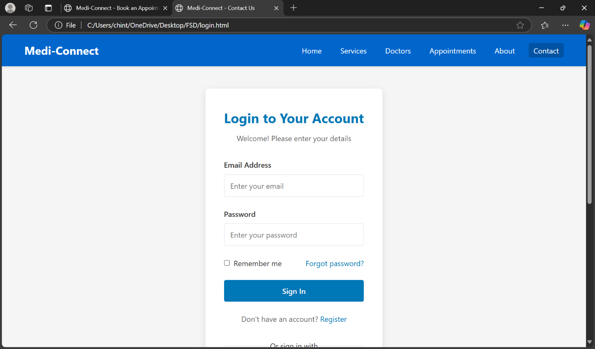

1. **SIGNUP PAGE:**

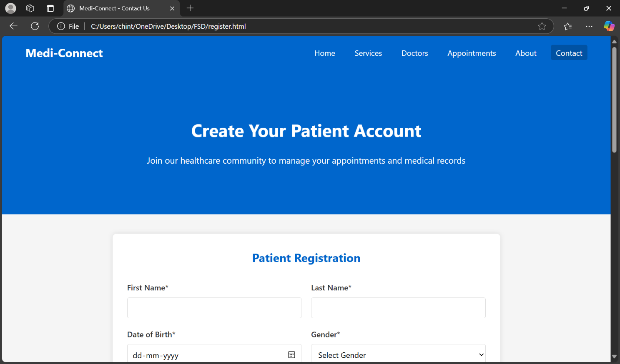

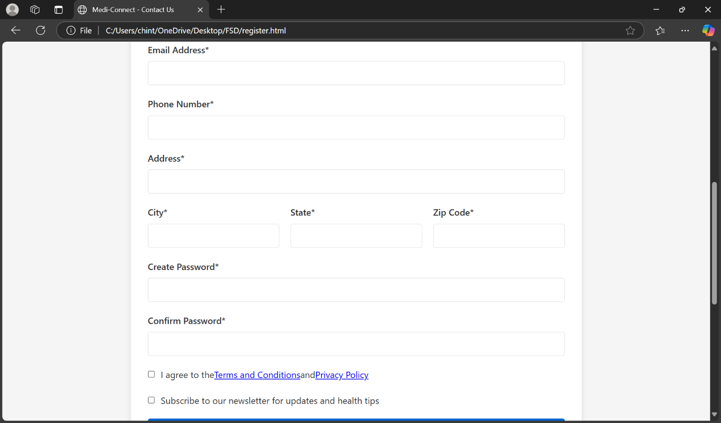

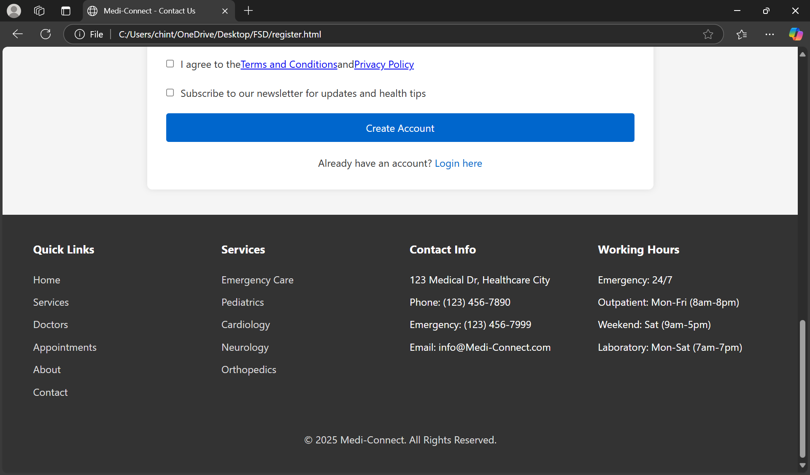

**3.HOMPEPAGE:**

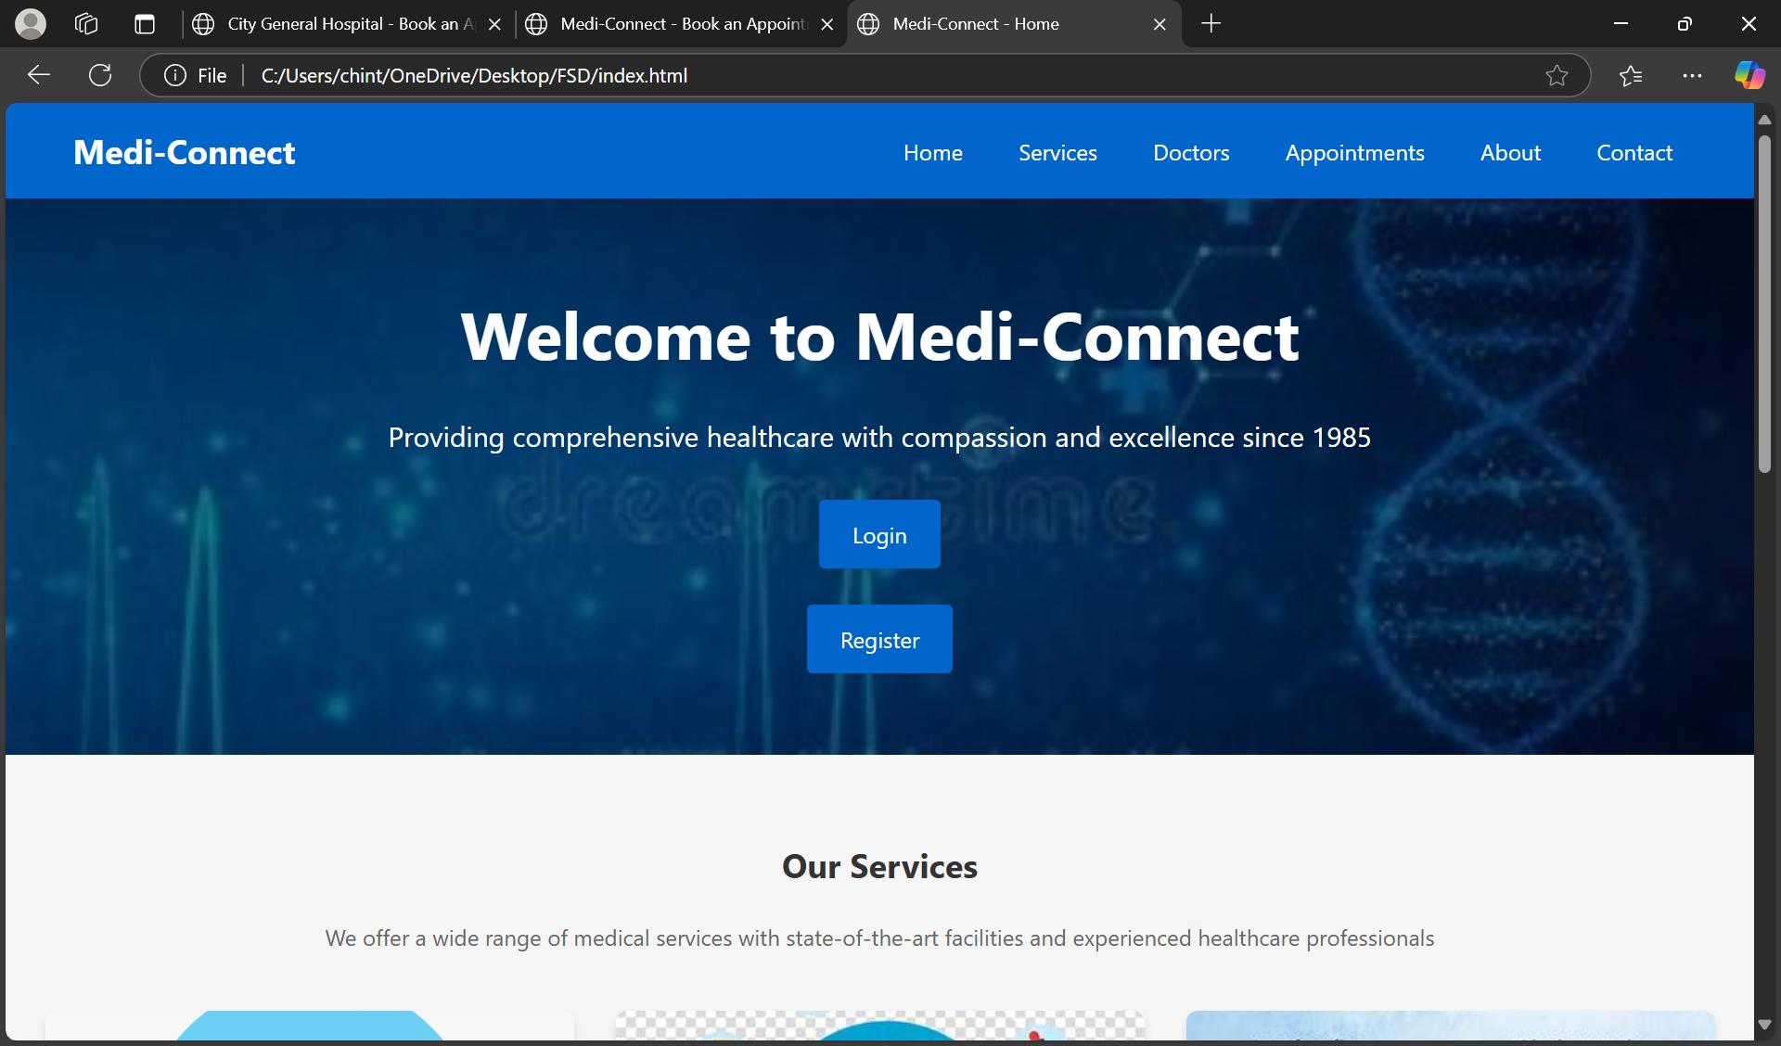

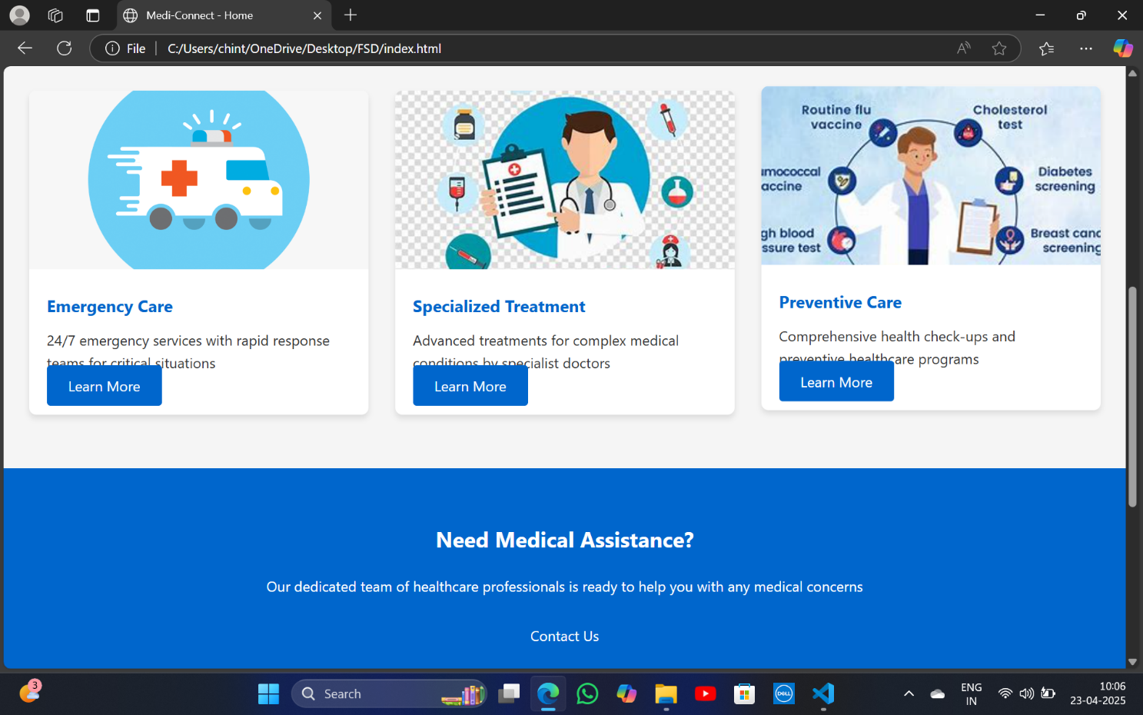

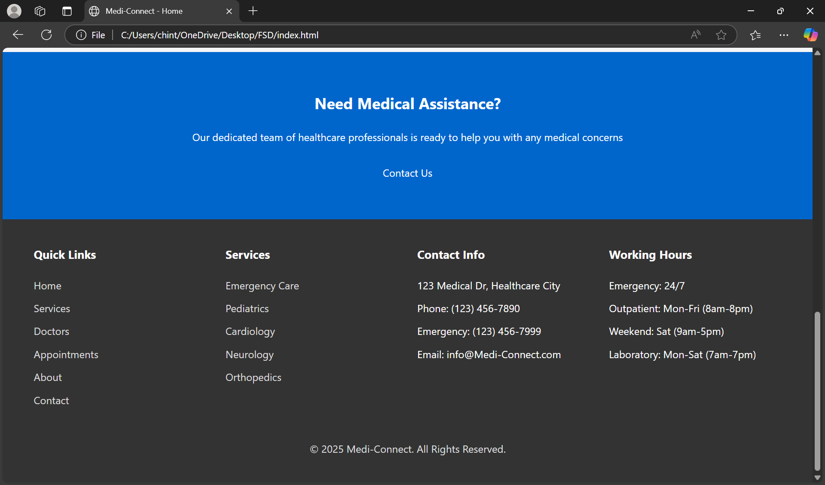

**4.SERVICES PAGE:**

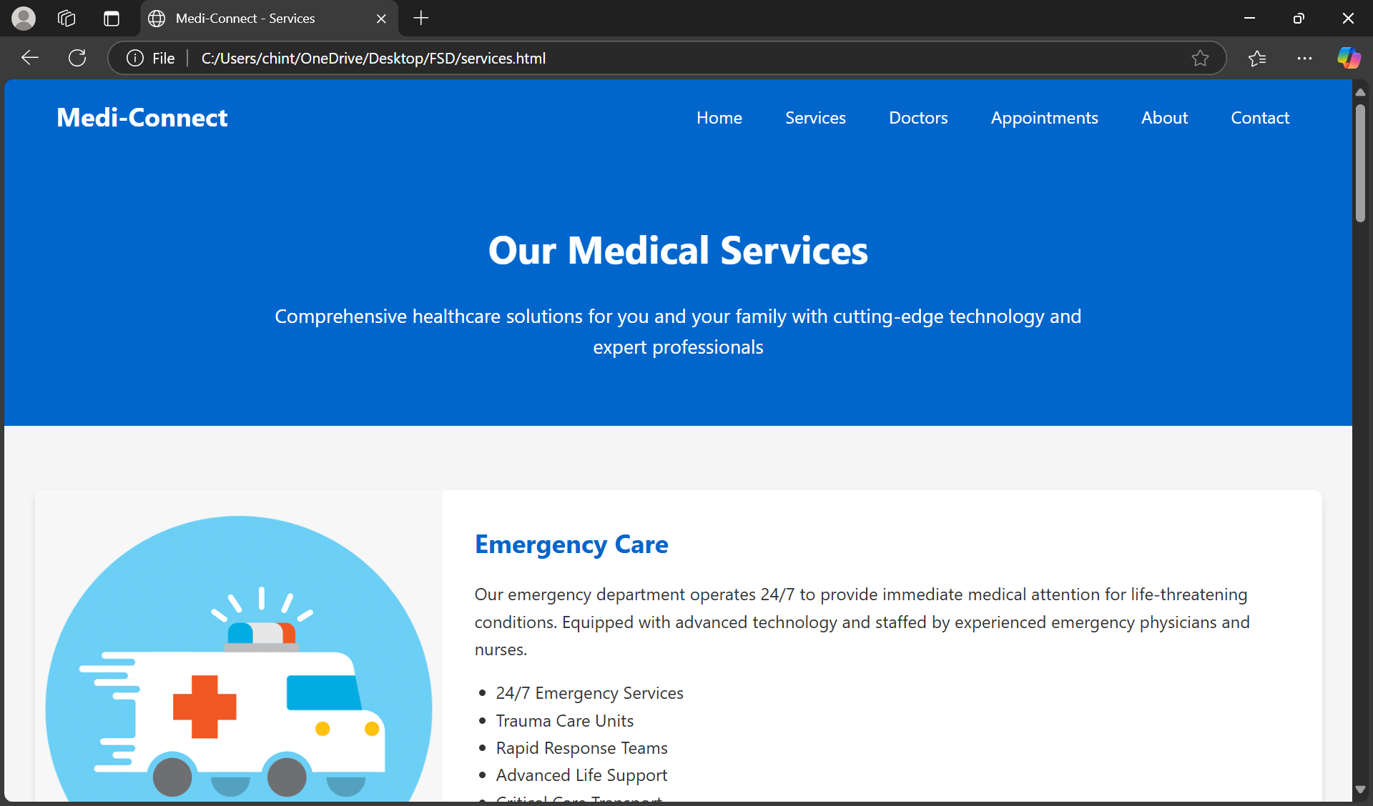

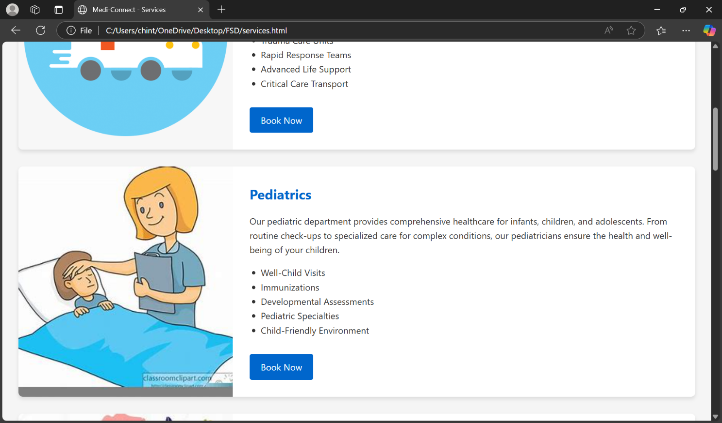

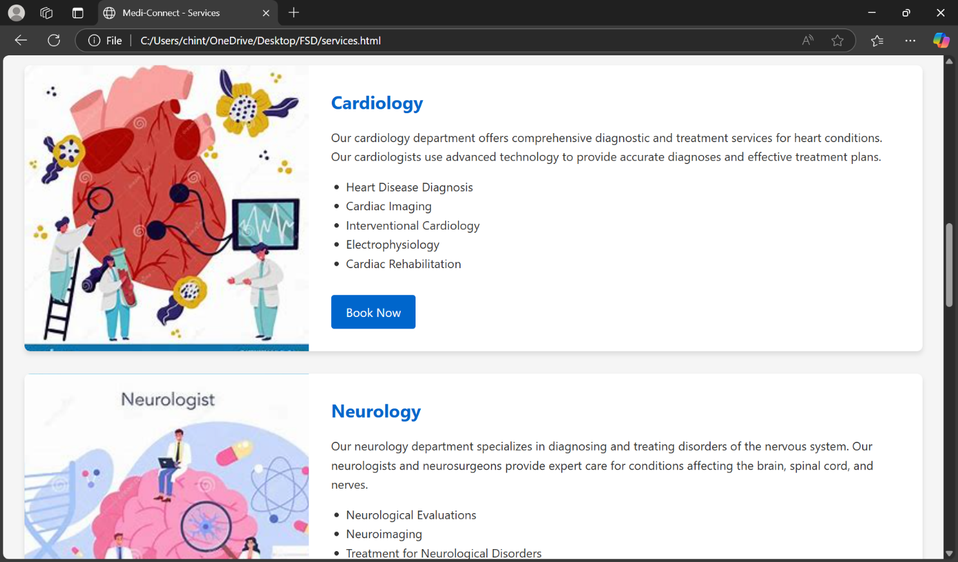

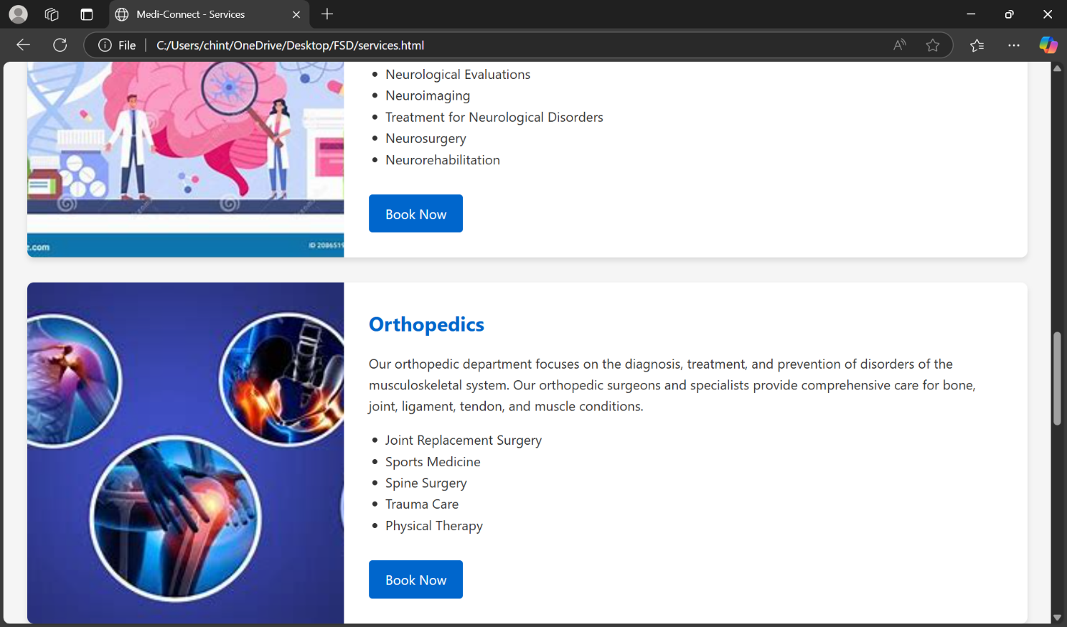

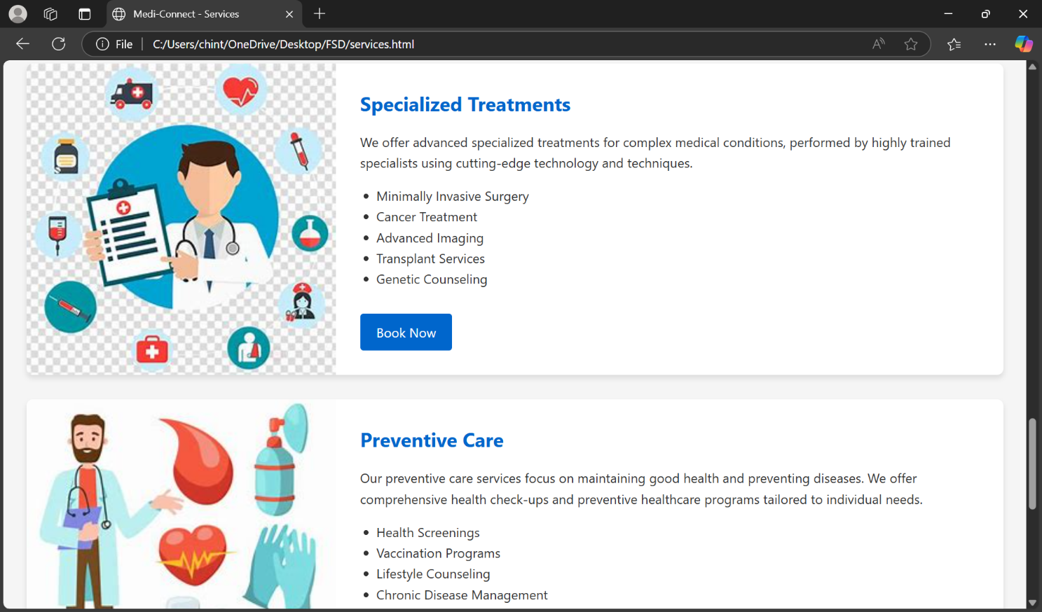

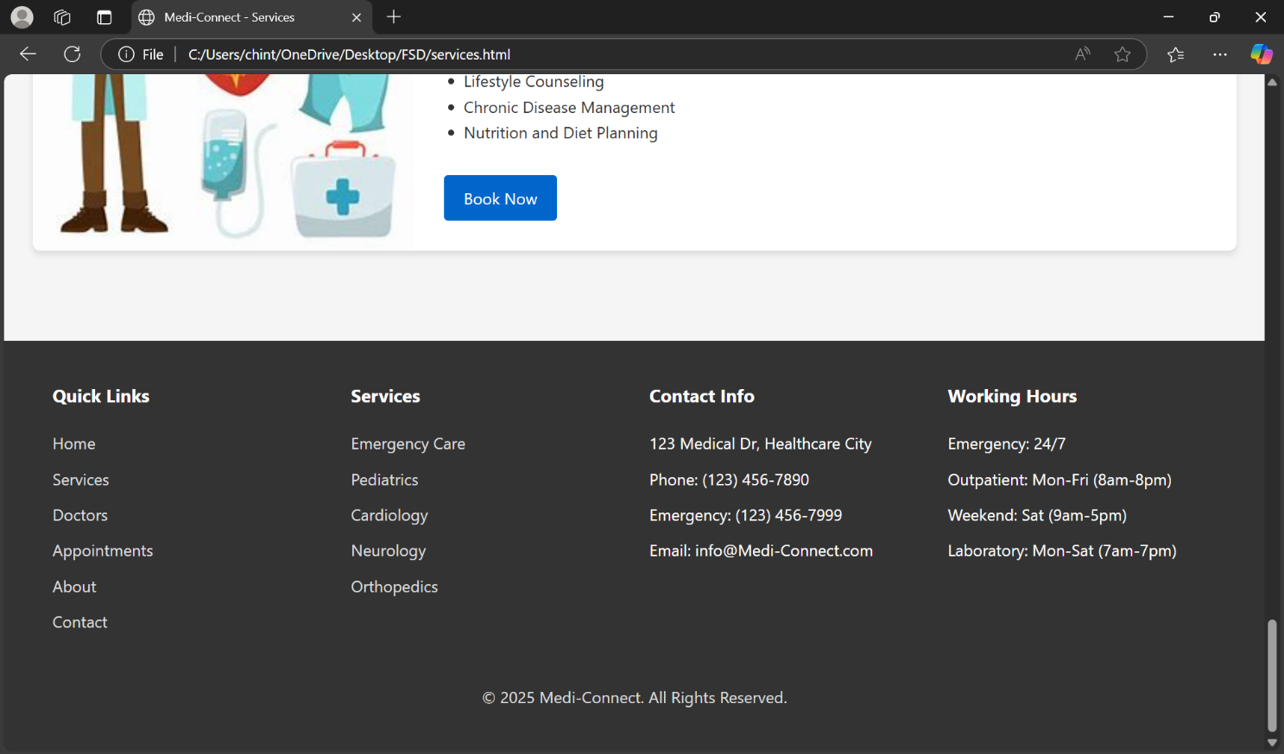

**5.DOCTORS PAGE:**

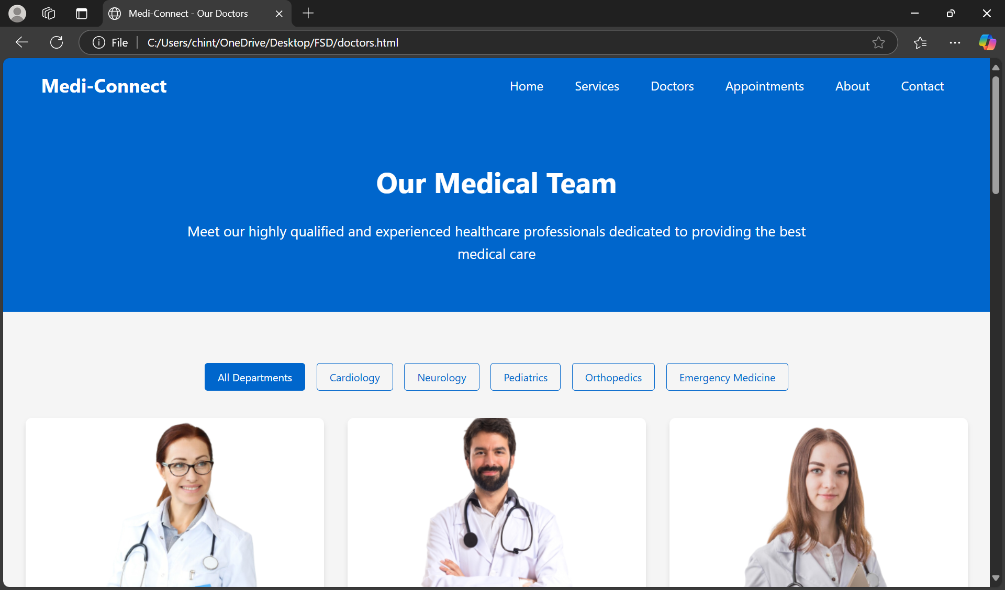

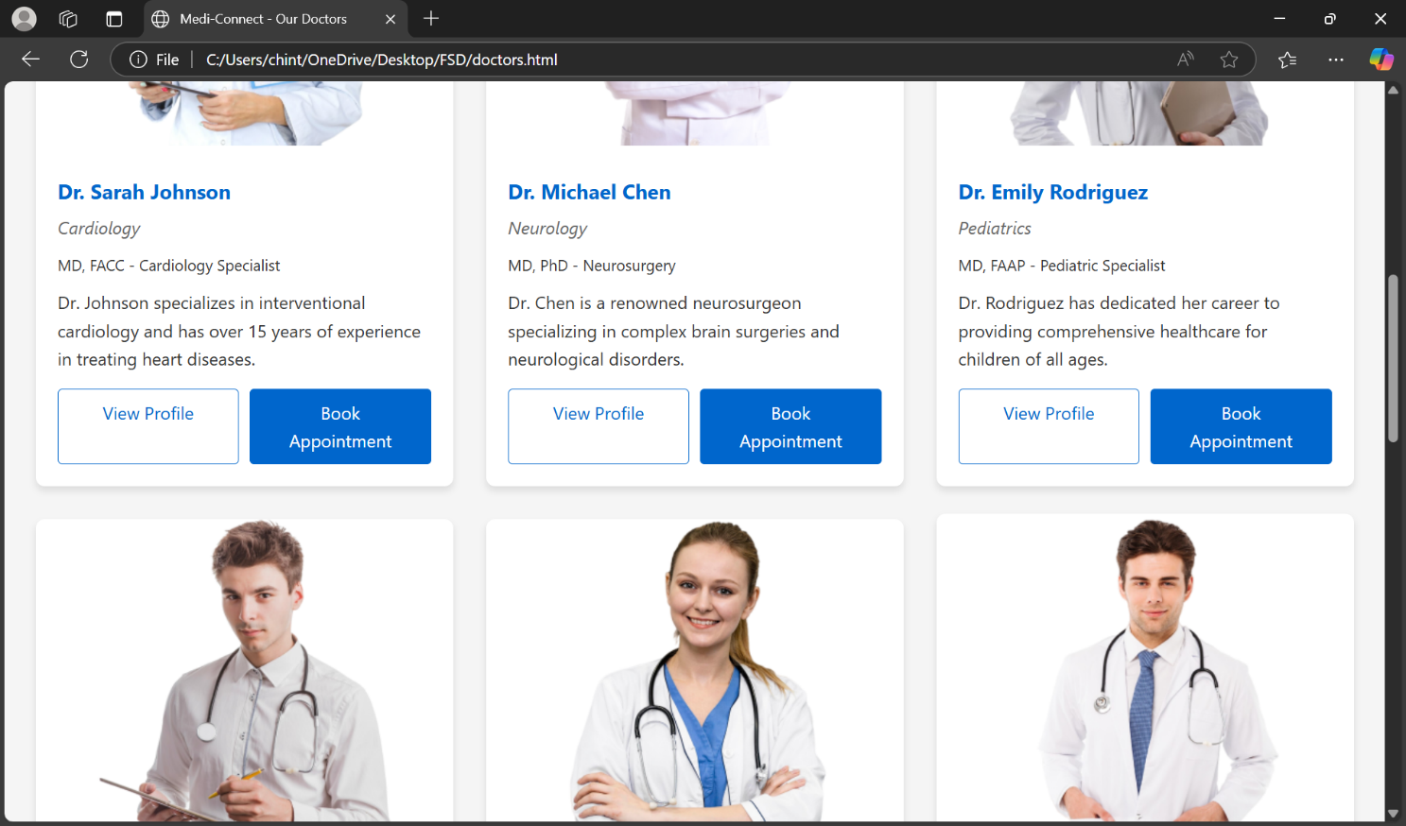

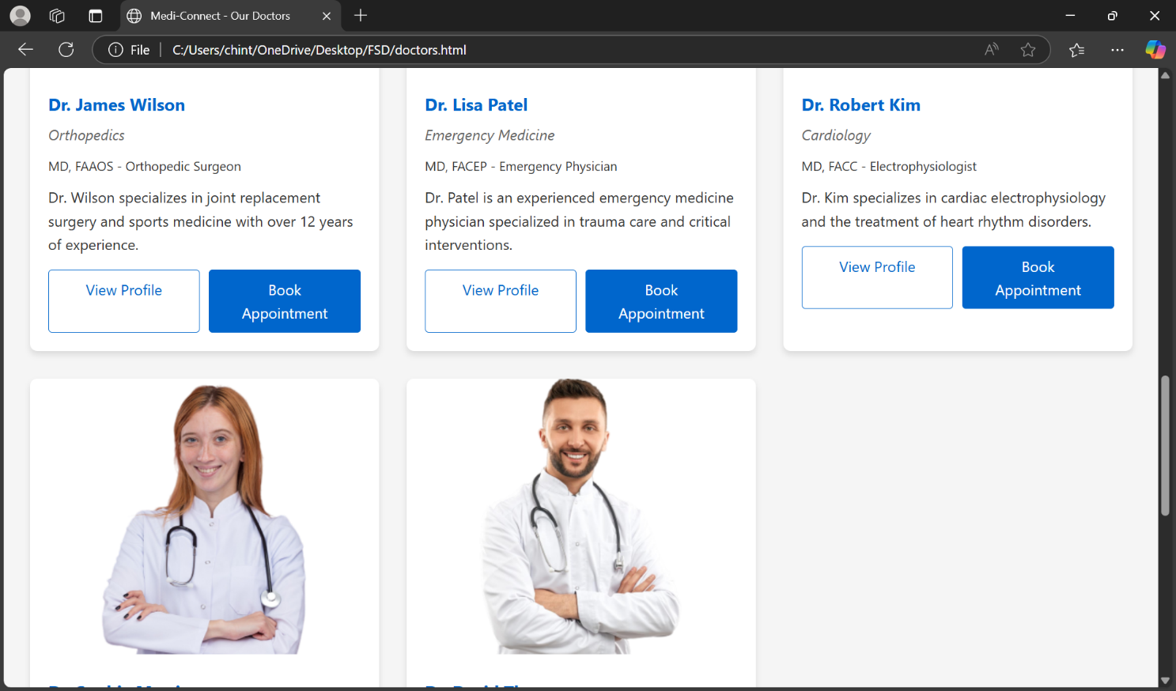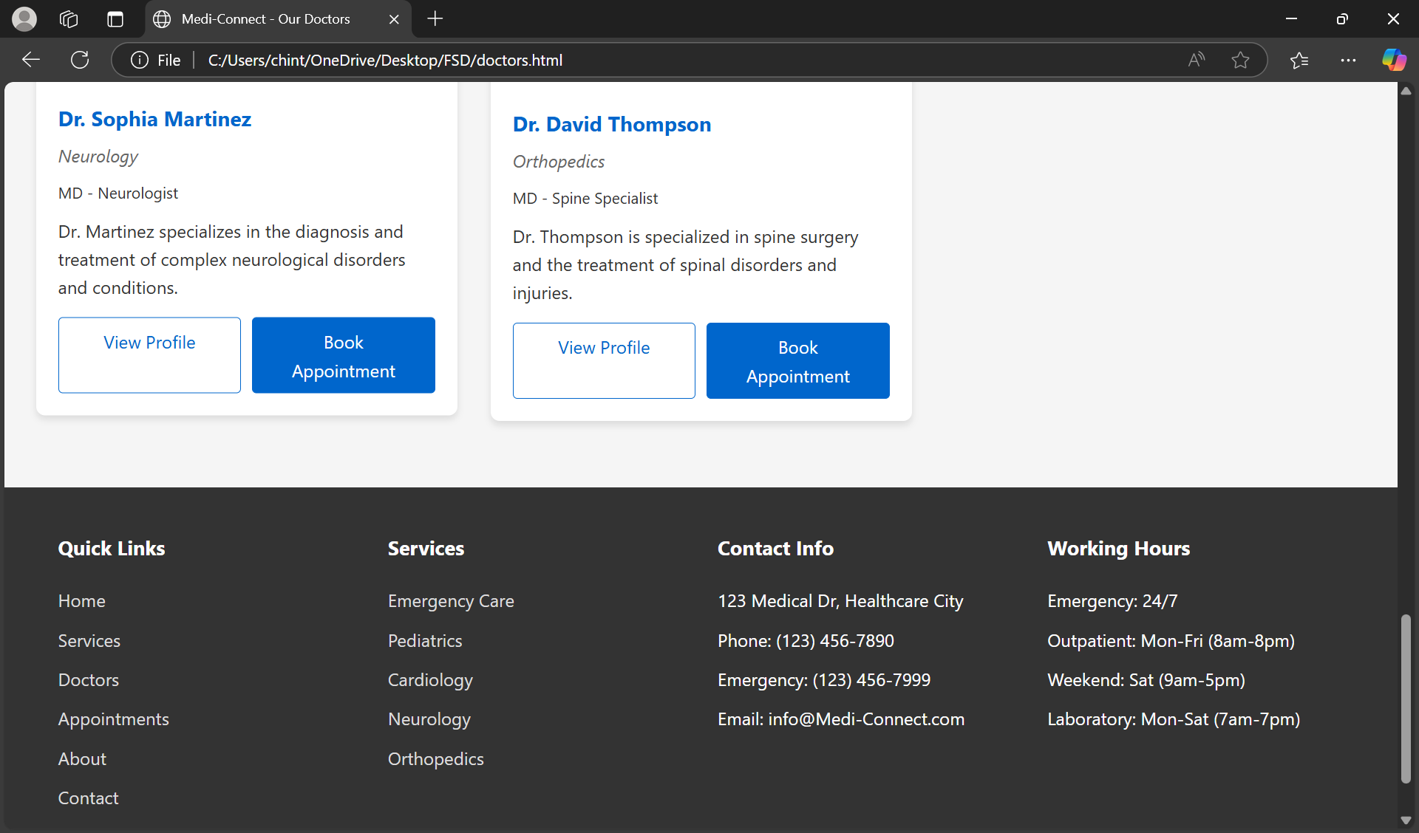

**6.APPOINTMENTS PAGE:**

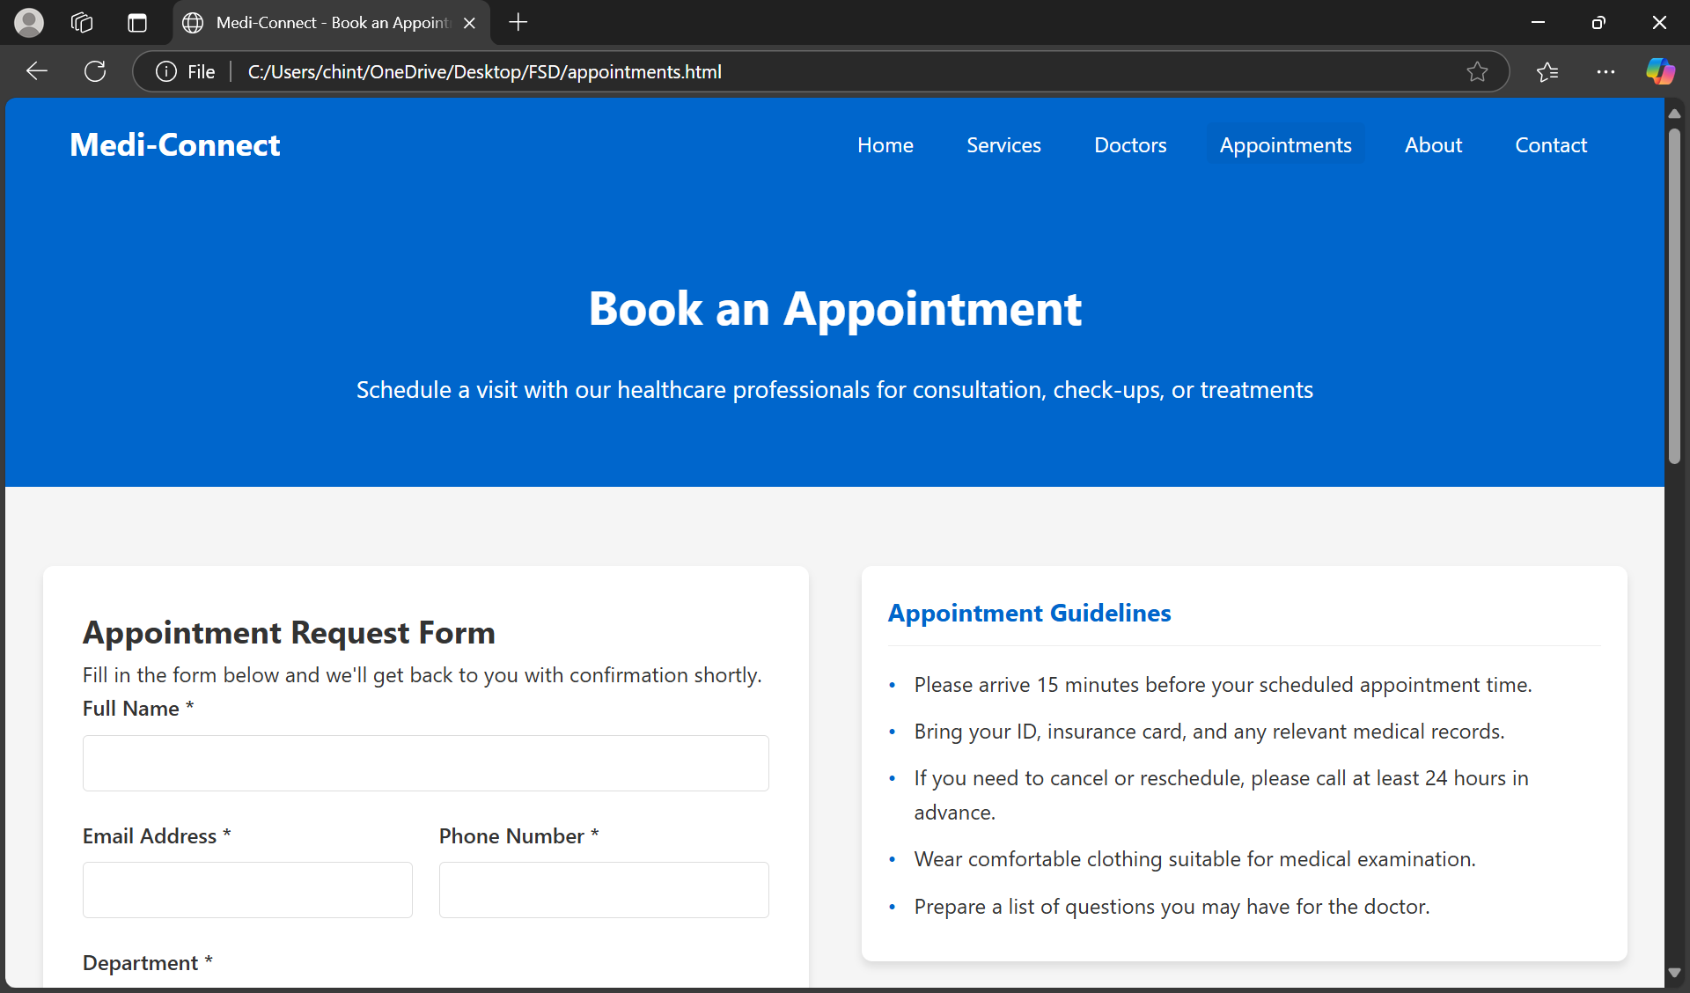

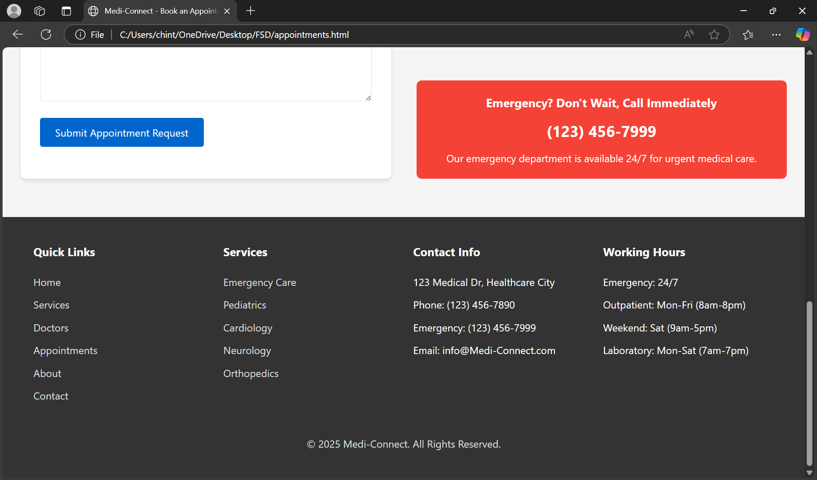

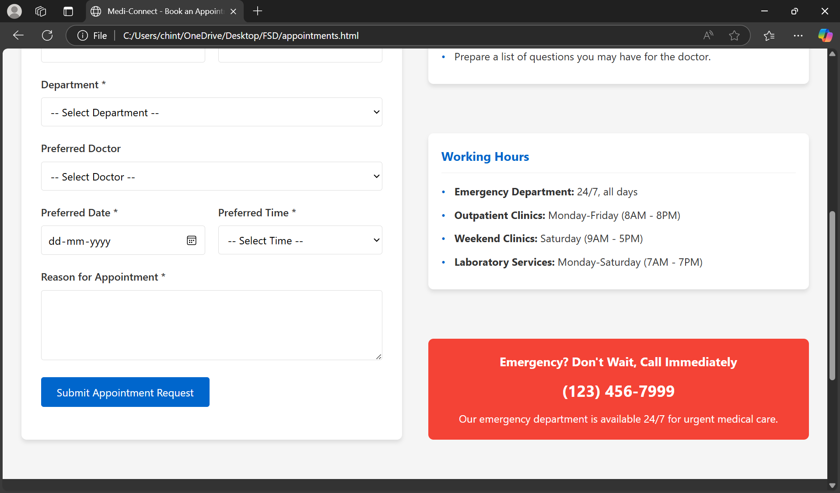

**7.ABOUT PAGE :**

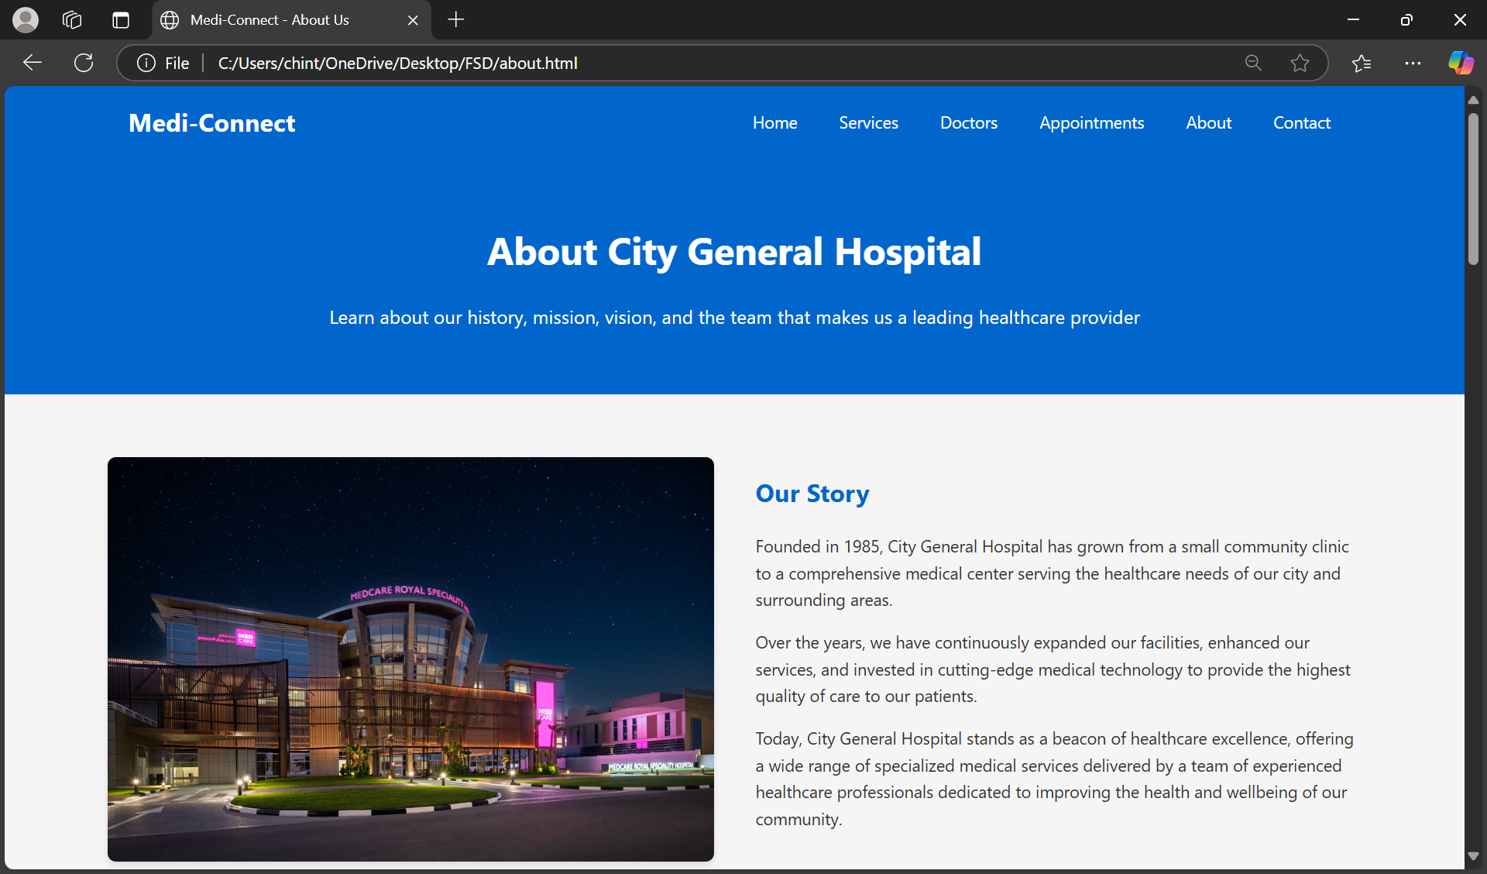

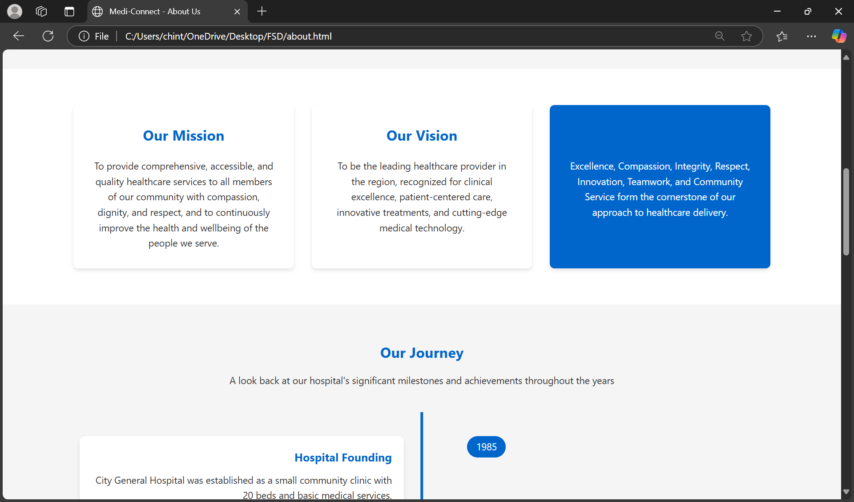

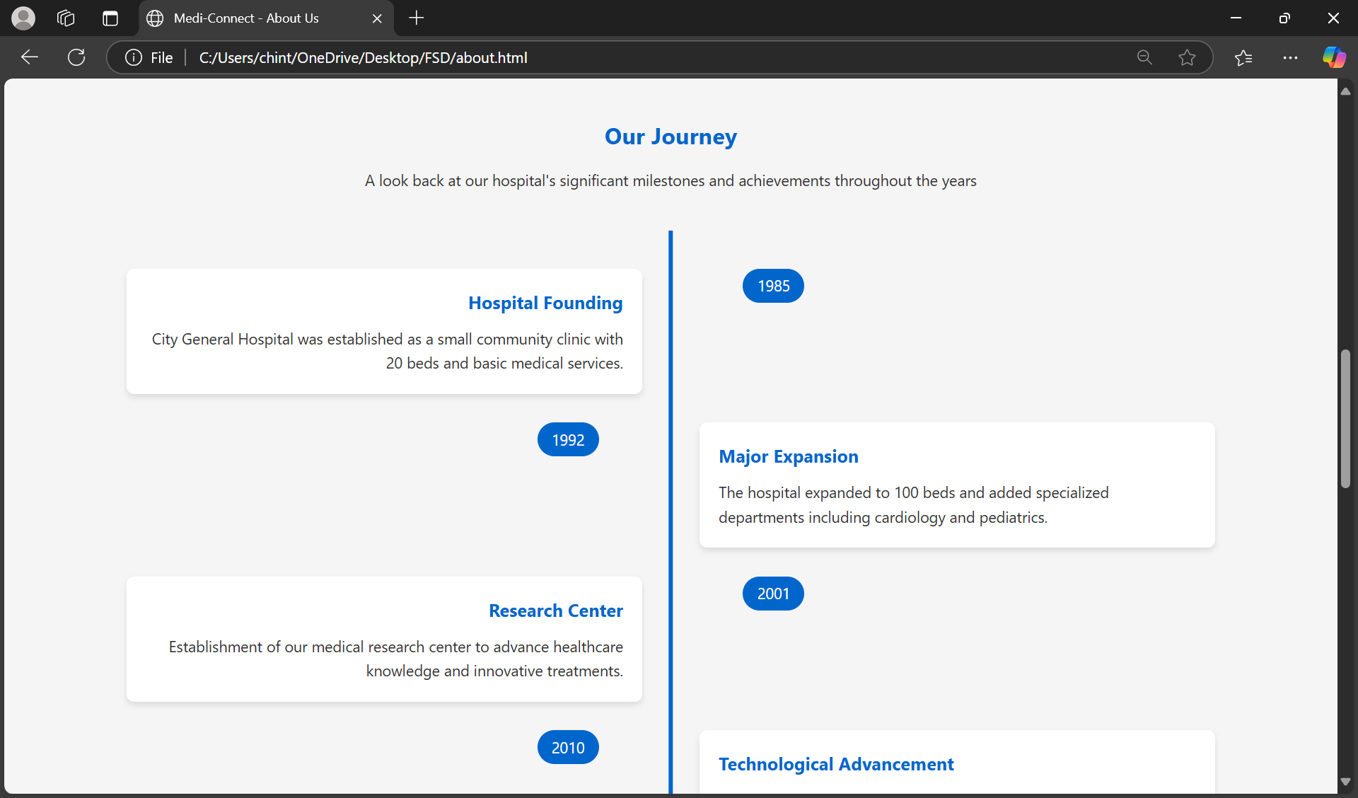

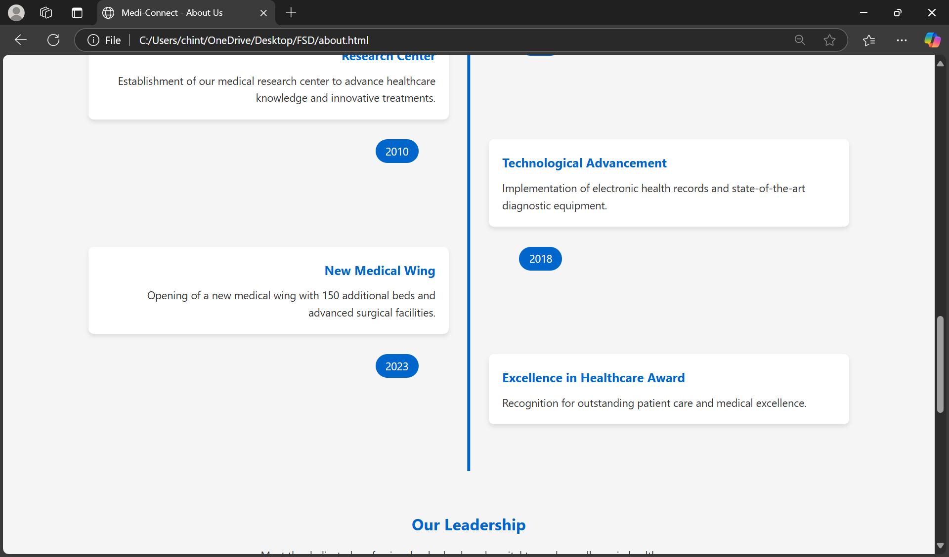

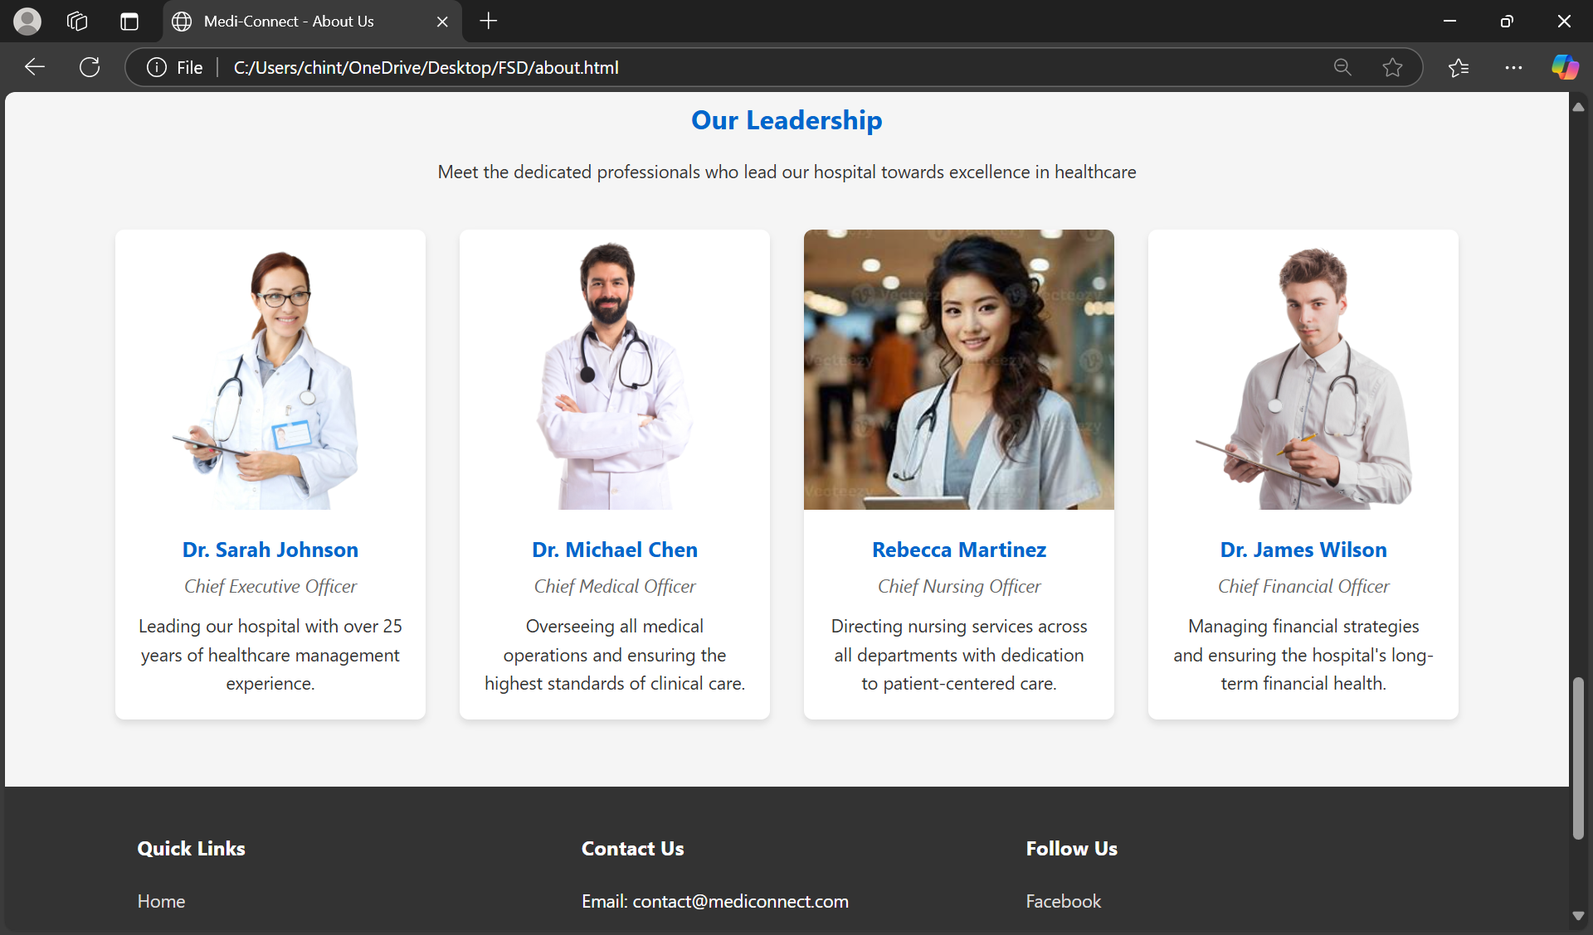

**8.CONTACT US**

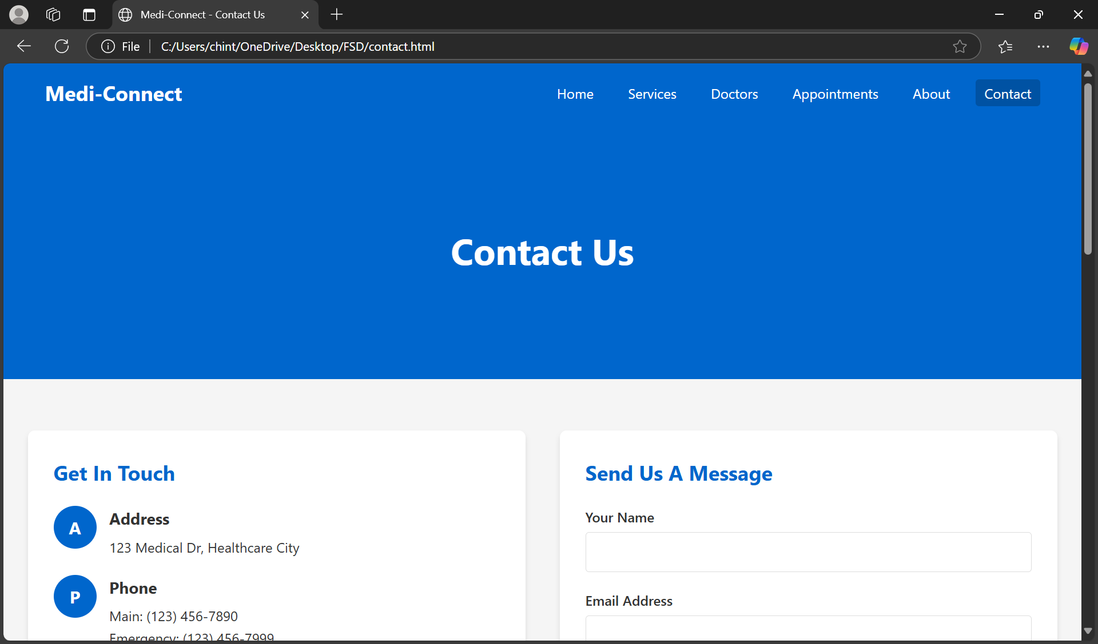

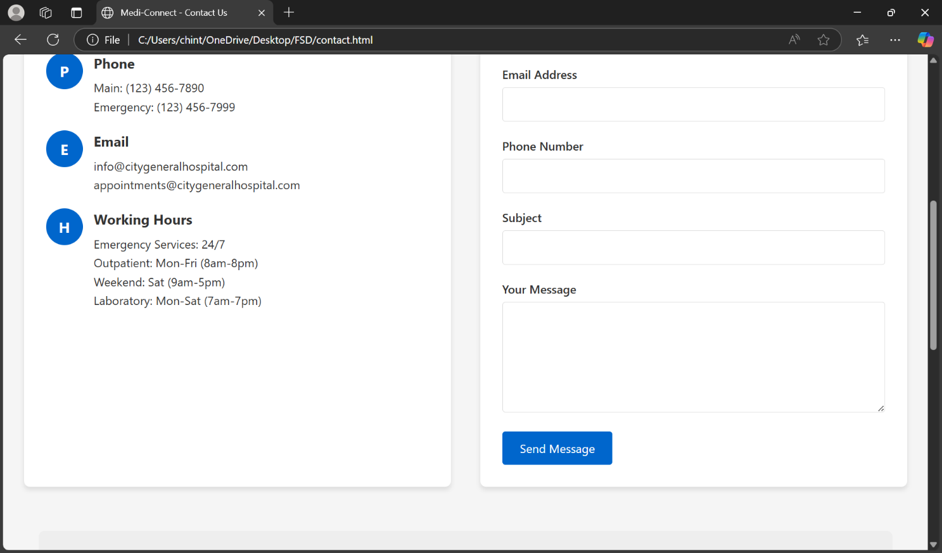

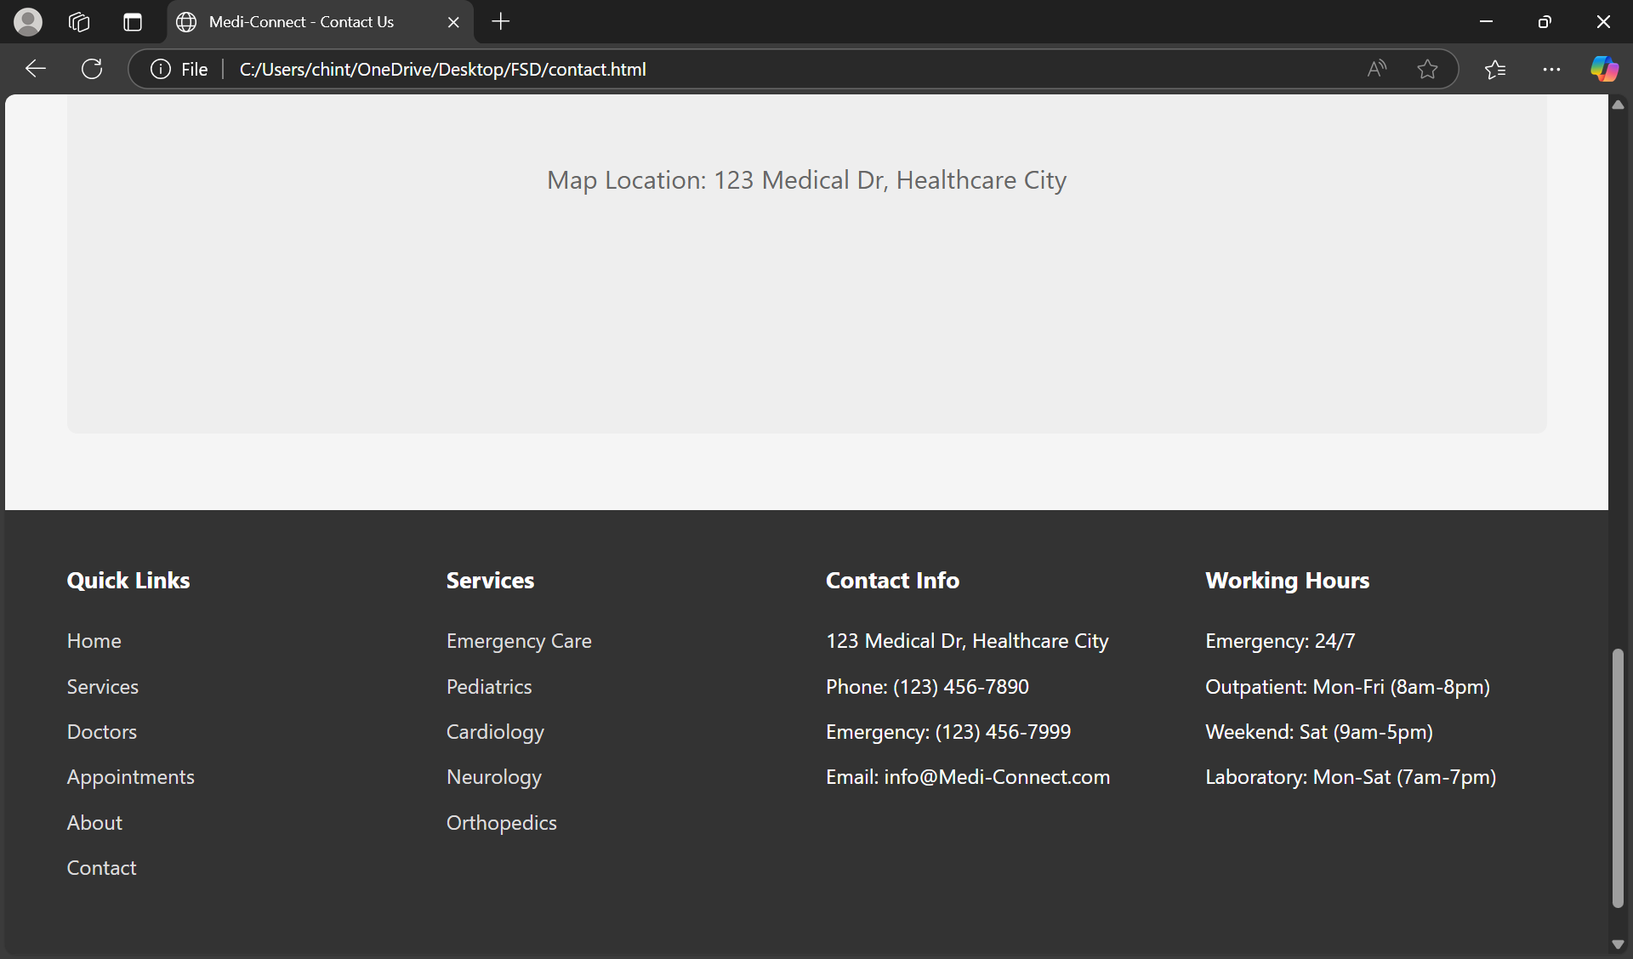

**8. LAB PROGRAMS**

**1 .Create your profile page i.e. educational details, Hobbies, Achievement, My Ideals etc using all basics tags in HTML.**

**PROGRAM:**

## Profilepage.html

<html>

<head>

<title>BIODATA (MY RESUME)</title>

<style>

</head>

<body bgcolor="pink">

<h1><b><u> Personal Details</u></b></h1>

<h2><b>Name:</b>D.Divakar</h2>

<b>Address:</b>7-166,subbaraopeta,kadiyam.<br>

<b>Date of Birth:</b> 07/05/2002<br>

<img src="photo.jpg" height="200px" width="150px"><br>

</body>

<h3><b>Educational Details:</b></h3>

<table border=1 cellspacing='0'>

<tr bgcolor="yellow">

<th>S.NO</th>

<th>Qualification</th>

<th>Name of the Institute</th>

<th>Year of Study</th>

<th>GPA</th>

</tr>

<td>1.</td>

<td>SSC</td>

<td>Sri Chaitanya School</td>

<td>2017-2018</td>

<td>9.8</td>

</tr>

<tr>

</tr>

<tr>

</tr>

</table>

<td>2.</td>

<td>Intermediate</td>

<td>Sri Chaitanya Junior College</td>

<td>2018-2020</td>

<td>9.94</td>

<td>3.</td>

<td>B.Tech(CSE)</td>

<td>Sagi Rama Krishnam Raju Engineering College </td>

<td>2020-2024</td>

<td> ---</td>

<h3><b>Skill Set:</b></h3>

<ul type="square">

<li>Playing cricket</li>

<li>Reading books</li>

<li>Listening music</li>

</ul>

<h3><b>About Me:</b></h3>

<p>I am D.Divakar Engineering student of CSE Department of 1/4 batch.<br>I choose CSE to get a good job with pakage in most affiliated company like Google, Microsoft etc... I hope I can reach my goal by studying in this college</p>

<h3><b>My Ideal:</b></h3>

<p>

My ideal is my parents.

</p>

</html>

**OUTPUT:**

**PROFILE PAGE**

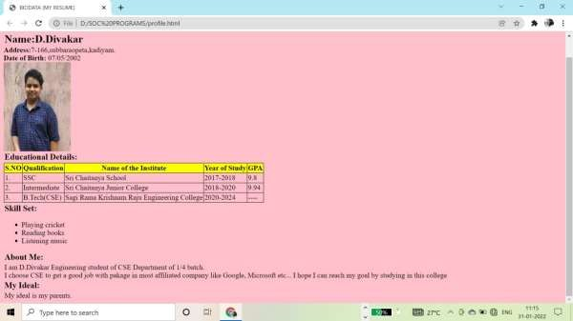

1. **Write an HTML code to illustrate the usage of the following:**
   * **Ordered List**
   * **Unordered List**
   * **Definition List PROGRAM:**

**List.html**

<html>

<head>

<title>Lists</title>

</head>

<body>

<h1>LISTS</h1>

<h3><u>UNORDERED LIST</u></h3>

<ul>

<li>Red</li>

<li>Green</li>

<li>Blue</li>

</ul>

<ul type="square">

<li>Violet</li>

<li>Indigo</li>

<li>Yellow</li>

</ul>

<h3><u>ORDERED LIST</u></h3>

<ol>

<li>CSE</li>

<ol type="a">

<li>AI</li>

<li>ML</li>

<li>AS</li>

</ol>

</ol>

<li>ECE</li>

<li>EEE</li>

<li>MECH</li>

<h3><u>DEFINITION LIST</u></h3>

<dl>

<dt>CSE:</dt>

<dd>Computer science engineering</dd>

<dt>ECE:</dt>

<dd>Electronics and communication engineering</dd>

<dt>EEE:</dt>

<dd>Electrical and electronics engineering</dd>

</dl>

</body>

</html>

**OUTPUT:**

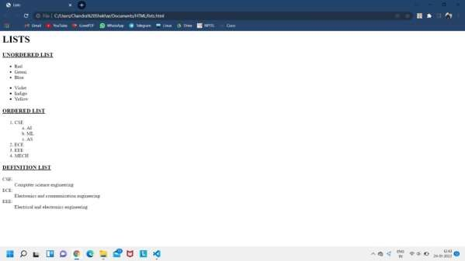

1. **Write an HTML code to create a Home page having three links: About Us, Our Services and Contact Us. Create separate web pages for the three links.**

**PROGRAM:**

**Homepage.html:**

<html>

<head>

<title>

homepage

</title>

<style>

</style>

</head>

<body>

<h1 align="center">HOME PAGE</h1>

<table align="center">

<tr>

<td><a href="aboutus.html">ABOUT US</a></td>

<td>&emsp;&emsp;&emsp;&emsp;<a href="ourservices.html">OUR SERVICES</a></td>

<td>&emsp;&emsp;&emsp;&emsp;<a href="contacus.html">CONTACT US</a></td>

</tr>

</table>

</body>

</html>

**Aboutus.html:**

<html>

<head>

<title>aboutus</title>

</head>

<body>

<h1 align="center">ABOUT US</h1>

<p>The website is about cricket related website. Now-a-days cricket is a popular game in our daily life.This website will display the teams which are playing cricket and players involved in the respective teams. Mainly there is no particular site to buy cricket related

things. This website provides the cricket related things at reasonable cost.The main advantage of this website is to know about match fixtures and their results.</p>

<p> This website displays a home page and there will be a login page. If the user doesn’t log in then user has to sign-up. The home page contains teams (for every team there will be players list and details about the players), match fixtures,points tables of tournaments, cricket shop, the cart and payment. In match fixtures there will be details about the match and its venue and the match timings. The user should add the interested items to the cart.

After adding the items to the cart, the user should proceed the payment. </p>

</body>

</html>

**Ourservices.html:**

<html>

<head>

<title>

ourservices

</title>

</head>

<body>

<h1 align="center">OUR SERVICES</h1>

<ol>

<li>Teams and their players</li>

<li>Matches-Which are recently and completed</li>

<li>Shop-To buy cricket related items</li>

</ol>

</body>

</html>

**Contactus.html:**

<html>

<head>

<title>

contactus

</title>

</head>

<body>

<h1 align="center">CONTACT US</h1>

<ol>

<li[>W](http://www.hatrickcricketadda.com/)W[W.hatrickcricketadda.com](http://www.hatrickcricketadda.com/)</li>

<li>Facebook-hatrickcricketadda</li>

<li>Instagram-HATRICKADDA</li>

</ol>

</body>

</html>

**OUTPUT:**

1. **homepage:**

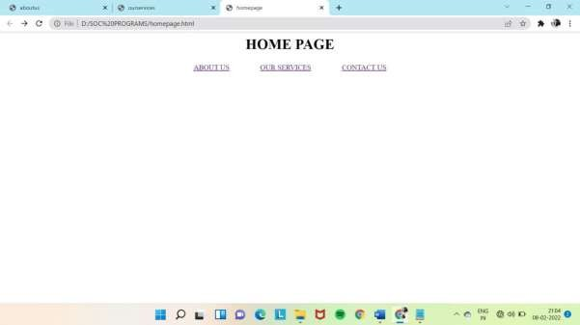

1. **aboutus:**

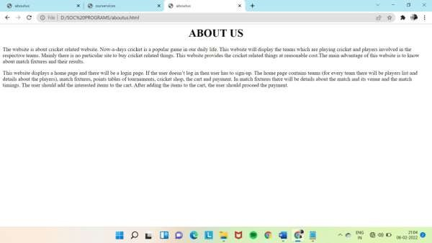

1. **ourservices:**

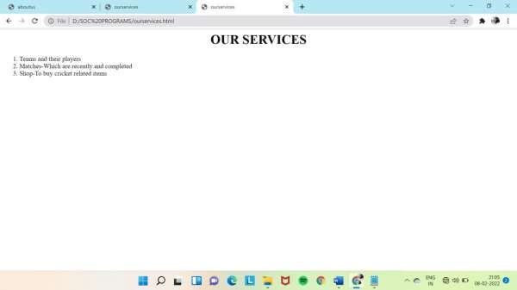

1. **contactus:**

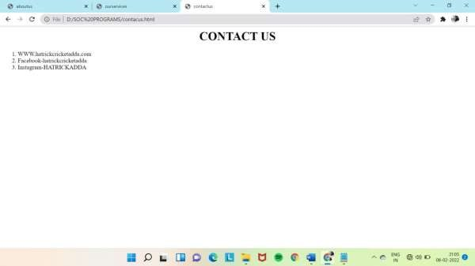

1. **Use table tag to format web page. Also create the Time Table of your class using table tag.**

**PROGRAM:**

## Table.html

<html>

<head>

<style>

table {

border-collapse: collapse; width: 50%;

}

td, th {

border: 1px solid #dddddd; text-align: left;

padding: 8px;

}

tr:nth-child(even) {

background-color: #dddddd;

}

</style>

</head>

<body>

<center>

<h2>Table</h2>

<table>

<tr>

<th>Year</th>

<th>Branch</th>

<th>No of students</th>

</tr>

<tr>

<td>1st year</td>

<td>CSE</td>

<td>300</td>

</tr>

<tr>

<td>1st year</td>

<td>ECE</td>

<td>210</td>

</tr>

<tr>

<td>2nd year</td>

<td>CSE</td>

<td>315</td>

</tr>

<tr>

<td>2nd year</td>

<td>ECE</td>

<td>250</td>

</tr>

<tr>

<td>3rd year</td>

<td>CSE</td>

<td>275</td>

</tr>

<tr>

<td>3rd year</td>

<td>ECE</td>

<td>200</td>

</tr>

</table>

</center>

</body>

</html>

**OUTPUT:**

**TABLE**

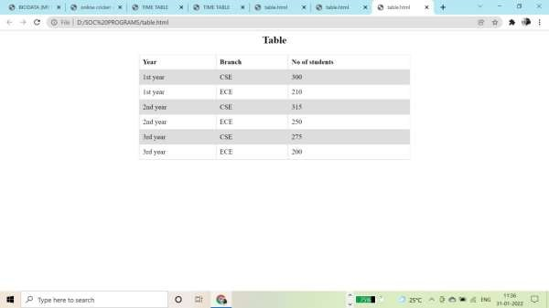

## Timetable.html

<html>

<head>

<title>TIME TABLE</title>

</head>

<body bgcolor="lavender">

<table align="center" border="1" cellpadding="10" width="1000" height="500">

<caption><u><b>Department of Computer Science and Engineering</b></u></caption>

<th>2/4 CSE-A</th>

<th colspan="6">2021-22 1st semester Timetable</th>

<th>Room</th>

<th>301</th>

<tr>

</tr>

<th>Day</th>

<th>1</th>

<th>2</th>

<th>3</th>

<th>4</th>

<th>5</th>

<th>6</th>

<th>7</th>

<th>8</th>

<tr align="center">

<th>Monday</th>

<td colspan="3">PP LAB</td>

<td>---</td>

<td colspan="2">PP</td>

<td colspan="2">ES</td>

</tr>

<tr align="center">

<th>Tuesday</th>

<td colspan="3">OS LAB</td>

<td>---</td>

<td colspan="2">SE</td>

<td colspan="2">M-III</td>

</tr>

<tr align="center">

<th>Wednesday</th>

<td colspan="2">OOP</td>

<td colspan="2">SE</td>

<td colspan="2">OS</td>

<td colspan="2">M-III</td>

</tr>

<tr align="center">

<th>Thursday</th>

<td colspan="2">PP</td>

<td colspan="2">OS</td>

<td colspan="3">OOP LAB</td>

<td>---</td>

</tr>

<tr align="center">

<th>Friday</th>

<td colspan="3">A1 & A2 WAD LAB</td>

<td>---</td>

<td colspan="2">OOP</td>

<td colspan="2">EP</td>

</tr>

<tr align="center">

</tr>

<th>Saturday</th>

<td colspan="2">---</td>

<td colspan="2">---</td>

<td colspan="4">---</td>

</table>

</body>

</html>

**OUTPUT:**

**TIME TABLE**

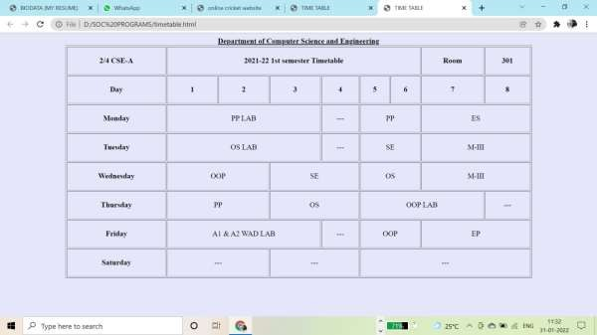

1. **Write an HTML code to create a login form. On submitting the form, the user should get navigated to a profile page.**

**PROGRAM:**

## Login.html

<html>

<head>

<title>login</title>

</head>

<body bgcolor="pink">

<center><h1><u>LOGIN</u></h1></center>

<form action="profile.html">

<table align="center">

<tr>

<td><b>USERNAME</b><br></td>

<td><input type="text" placeholder="enter user name" required></td>

</tr>

<tr>

<td><b>PASSWORD</b><br></td>

<td><input type="PASSWORD" placeholder="enter password" MINLENGTH="8" required></td>

</tr>

<tr>

<td colspan="2" align=""center ><a href="profile.html"><button>LOGIN</button></a><br>

</tr>

</table>

</form>

</div>

</body>

</html>

**OUTPUT:**

**LOGIN PAGE**

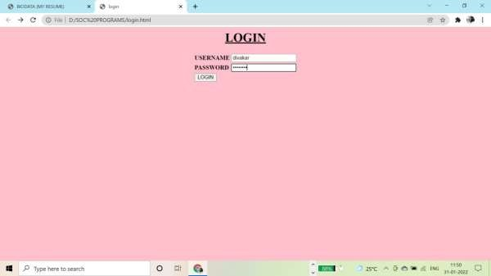

## Profilepage.html

<html>

<head>

<title>BIODATA (MY RESUME)</title>

<style> h1,

h2,

h3,

p{

padding:1px; margin:1px;

}

</style>

</head>

<body bgcolor="pink">

<h1><b><u> Personal Details</u></b></h1>

<h2><b>Name:</b>G.Sri.Chandra Shekhar</h2>

<b>Address:</b>24-4-9/3,Weavers colony,Korukonda Road,Rajahmundry.<br>

<b>Date of Birth:</b> 16/08/2003<br>

<img src="C:\Users\Chandra Shekhar\Documents\MY PERSONALS\AADHHAR_JPG\SHEKHAR.jpg" height="200px" width="150px"><br>

</body>

<h3><b>Educational Details:</b></h3>

<table border=1 cellspacing='0'>

<tr bgcolor="yellow">

<th>S.NO</th>

<th>Qualification</th>

<th>Name of the Institute</th>

<th>Year of Study</th>

</tr>

<tr>

</tr>

<tr>

</tr>

<tr>

</tr>

<tr>

</tr>

</table>

<th>Place of the Institute</th>

<th>GPA</th>

<td>1.</td>

<td>1-9</td>

<td>Minerva </td>

<td>2008-2013</td>

<td>Prathipadu</td>

<td>96%</td>

<td>2.</td>

<td>SSC</td>

<td>Prathibha Edu-Care </td>

<td>2017-2018</td>

<td>Rajahmundry</td>

<td>9.8</td>

<td>3.</td>

<td>Intermediate</td>

<td>Sri Chaitanya Junior College</td>

<td>2018-2020</td>

<td>Rajahmundry</td>

<td>9.94</td>

<td>4.</td>

<td>B.Tech(CSE)</td>

<td>Sagi Rama Krishnam Raju Engineering College </td>

<td>2020-2024</td>

<td>Bhimavaram</td>

<td>---</td>

<h3><b>Skill Set:</b></h3>

<ul type="square">

<li>Making Crafts</li>

<li>Drawing</li>

<li>Playing Chess</li>

<li>Reading Books</li>

<li>Watching Movies</li>

</ul>

<h3><b>About Me:</b></h3>

<p>I am G.Sri Chandra Shekhar Engineering student of CSE Department of 1/4 batch.<br>I choose CSE to get a good job with pakage in most affiliated company like Google, Microsoft etc... I hope I can reach my goal by studying in this college

</p>

<h3><b>My Ideal:</b></h3>

<p>

My ideal is my parents.

</p>

</html>

**OUTPUT:**

**PROFILE PAGE**

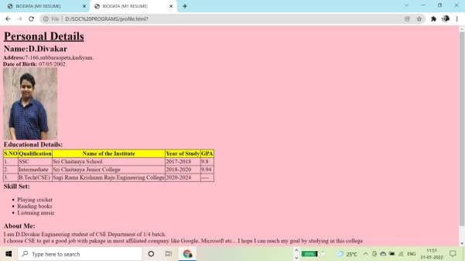

1. **Write an HTML code to create a Registration Form. On submitting the form, the user should be asked to login with this new credentials.**

**PROGRAM:**

## Registration.html

<html>

<head>

<title>

Registration form</title>

</head>

<body bgcolor="pink">

<h2><center>Registration form</center></h2>

<form action="login.html">

<table align="center">

<tr>

<td>UserName:</td>

<td><input type="text" placeholder="FULL NAME"></td>

</tr>

<tr>

<td>Mobile Number:</td>

<td><input type="tel" maxlength="10" placeholder="123-456-7890"></td>

</tr>

<tr>

<td>Email:</td>

<td><input type="email" placeholder="Email"></td>

</tr>

<tr>

<td>Password:</td>

<td><input type="password" minlength="8" placeholder="Password"></td>

</tr>

<tr>

<td>ConformPassword:</td>

<td><input type="password" minlength="8" placeholder="Password"></td>

</tr>

<tr align="center">

<td><button value="submit" action="login.html">SUBMIT</button></td>

<td><button value="reset">RESET</button></td>

</tr>

</table>

</form>

</body>

</html>

**OUTPUT:**

**REGISTRATION PAGE**

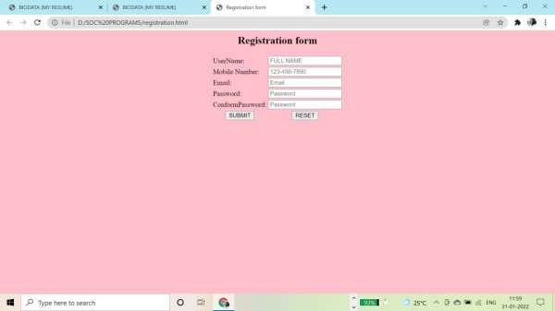

## Login.html

<html>

<head>

<title>login</title>

</head>

<body bgcolor="pink">

<center><h1><u>LOGIN</u></h1></center>

<form action="profile.html">

<table align="center">

<tr>

<td><b>USERNAME</b><br></td>

<td><input type="text" placeholder="enter user name" required></td>

</tr>

<tr>

<td><b>PASSWORD</b><br></td>

<td><input type="PASSWORD" placeholder="enter password" MINLENGTH="8" required></td>

</tr>

<tr>

<td colspan="2" align=""center ><a href="profile.html"><button>LOGIN</button></a><br>

</tr>

</table>

</form>

</div>

</body>

</html>

**OUTPUT:**

**LOGIN PAGE**

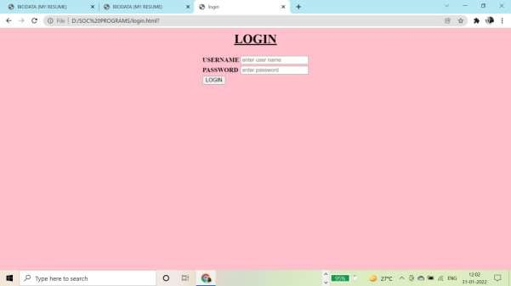

1. **Write an HTML code to create a frameset having header, navigation and content sections.**

**PROGRAM:**

## Main.html

<html>

<head>

<title>SRKREC</title>

</head>

<frameset rows="20%,5%,*" border="0">

<frame name="top" src="top.html" />

<frame name="toolbar" src="toolbar.html" />

<frameset cols="15%,*,15%">

<frame name="left" src="left.html" />

<frame name="middle" src="middle.html" />

<frame name="right" src="right.html" />

</frameset>

</frameset>

</html>

## Top.html

<html>

<head>

</head>

<body>

<table align="center">

<tr>

<td><img src="download.png" height=100 width=700></td>

</tr>

</table>

</body>

</html>

## Toolbar.html

<html>

<body bgcolor="grey">

<center>

<table border=0 width=100%>

<tr align=" center">

<td><a href="middle.html" target="middle">Home</a></td>

<td><a href="[http://www.srkrec.edu.in/intake.php"](http://www.srkrec.edu.in/intake.php) target="middle">Admissions</a></td>

<td><a href="<http://www.srkrec.edu.in/files/SYLLABUS/R20/CSE-R20-> Syllabus.pdf"

target="middle">Syllabus</a>

</td>

<td><a href="[http://www.srkrec.edu.in/college_profile.php"](http://www.srkrec.edu.in/college_profile.php) target="middle">About College</a></td>

</tr>

</table>

</center>

</body>

</html>

## Left.html

<html>

<head>

</head>

<body bgcolor="skyblue" align="left">

<h3>

<ul type="square">

<li><a href="[http://www.srkrec.edu.in/intake.php"](http://www.srkrec.edu.in/intake.php) target="middle">Admissions</a></li>

<li><a href="<http://www.srkrec.edu.in/files/SYLLABUS/R20/CSE-R20-> Syllabus.pdf" target="middle">Syllabus</a>

</li>

<li><a href="[http://www.srkrexams.in/Login.aspx"](http://www.srkrexams.in/Login.aspx) target="middle">Result</a> </li>

<li><a href="[http://www.srkrec.edu.in/college_profile.php"](http://www.srkrec.edu.in/college_profile.php) target="middle">About College</a> </li>

<li><a href="https://[www.google.com/maps/embed?pb=!1m18!1m12!1m3!1d3824.6622013921196!](http://www.google.com/maps/embed?pb=!1m18!1m12!1m3!1d3824.6622013921196!) 2d81.49421901486477!3d16.543142788589645!2m3!1f0!2f0!3f0!3m2!1i1024!2i768!4f13.1!

3m3!1m2!1s0x3a362d5e7ef94f99%3A0x3a2b78f9b48493fe!2sSRKR%20Engineering%20C ollege!5e0!3m2!1sen!2sin!4v1637054984894!5m2!1sen!2sin"

target="middle">College Map</a> </li>

</ul>

</h3>

</body>

</html>

## Middle.html

<html>

<head>

</head>

<body align="Center" bgcolor="green">

<h1>Hello Student</h1>

<h1>Welcome to SRKR Engineering College</h1>

</body>

</html>

## Right.html

<html>

<body bgcolor="skyblue">

<marquee behavior="scroll" direction="left"><a href=""> click here I-II Result are out...</a></marquee>

</body>

</html>

**OUTPUT:**

**FRAMES**

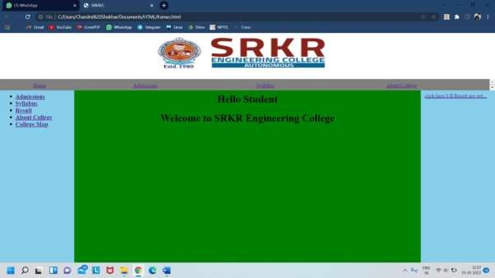

## Write an HTML code to demonstrate the usage of inline CSS. PROGRAM:

<html>

<head>

<title>inlinecss</title>

</head>

<body>

<h1 style="color:blue;text-decoration:underline;font-family:Times New Roman;text- align:center;">CSS</h1>

<p style="font-size:18px;color:red;font-family:Times New Roman;">

Cascading Style Sheets (CSS) is a style sheet language used for describing the presentation of a document written in a markup language such as HTML.

CSS is a cornerstone technology of the World Wide Web, alongside HTML and JavaScript.

</p>

<h1 style="color:blue;text-decoration:underline;font-family:Times New Roman;text- align:center;">HTML</h1>

<p style="font-size:18px;color:red;font-family:Times New Roman;">

The HyperText Markup Language, or HTML is the standard markup language for documents designed to be displayed in a web browser.

It can be assisted by technologies such as Cascading Style Sheets (CSS) and scripting languages such as JavaScript.

</p>

</body>

</html>

**OUTPUT:**

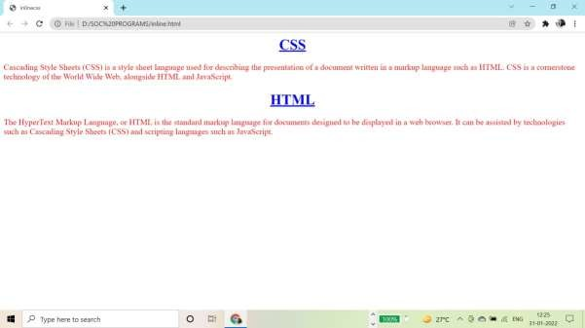

## Write an HTML code to demonstrate the usage of internal CSS. PROGRAM:

<html>

<head>

<title>internalcss</title>

<style> h1

{

color:blue;

text-decoration:underline;

font-family:Times New Roman; text-align:center;

}

p

{

font-size:18px; color:red;

font-family:Times New Roman;

}

</style>

</head>

<body>

<h1>CSS</h1>

<p ">

Cascading Style Sheets (CSS) is a style sheet language used for describing the presentation of a document written in a markup language such as HTML.

CSS is a cornerstone technology of the World Wide Web, alongside HTML and JavaScript.

</p>

<h1>HTML</h1>

<p>

The HyperText Markup Language, or HTML is the standard markup language for documents designed to be displayed in a web browser.

It can be assisted by technologies such as Cascading Style Sheets (CSS) and scripting languages such as JavaScript.

</p>

</body>

</html>

**OUTPUT:**

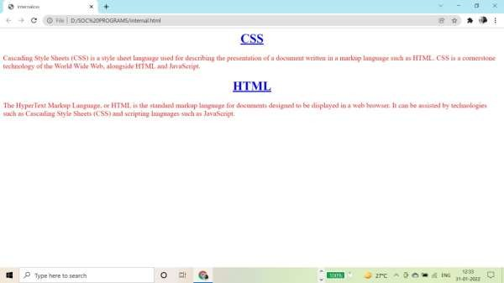

## Write an HTML code to demonstrate the usage of external CSS. PROGRAM:

Shop.html:

<html>

<head>

<title>online cricket website</title>

<link rel="stylesheet" href="style.css">

</head>

<body>

<h1 align=”center”>127951SHOP&#127951</h1>

<table class="shop">

<tr><td align="center"><img src="spartan.jpg" class="items"><br> SPARTAN bat<br>1100/-<br>4.4★<br>

Deliver within one week<br>

<a href="cartmessage.html"><button>ADD TO CART</button></a></td>

<td align="center"><img src="kball.jpg" class="items"><br> KOOKABURRA ball<br>800/-<br>4.6★<br>

Deliver within one week<br>

<a href="cartmessage.html"><button>ADD TO CART</button></a></td></tr>

</table>

</body>

</html>

**Style.css:**

.shop

{

font-size: 20px; color:burlywood; width: 100%;

border: 2;

}

.items

{

border-radius: 40%; width: 150px; height: 200px; padding: 40px;

}

image

{

width: 70px; height: 70px;

}

**OUTPUT:**

